SIG Workshop Elastic Search & Kibana

20th February 2018

Elastic Search [Index]: NoSQL, REST API, distributed, highly available. Great for searching. Well integrated from Log Stash (for gathering and loading data, in real time, for example from log files) and Kibana (for exploring and visualizing data in the Search Index.

In this workshop:

* Get Elastic Search and Kibana up and running in a local Docker based environment
  + Optionally: use cloud based environment
* Create an Elastic Search Index through the REST API and experiment with search options
* Leverage Kibana to explore the search index [documents] in a user friendly, visual way and create several visualizations (tag cloud, geographic map, bar chart, …) on top of the data
* Try out the combination of LogStash, Elastic Search and Kibana for gathering, storing, querying and analyzing log files – in a fully hosted environment

### Resources

Elastic Documentation:

Sources for this workshop: <https://github.com/lucasjellema/sig-elasticsearch-february-2018>

# 1. Prepare your environment

We assume a Docker host on which you can start containers.

Alternatives in case you do not have Docker available to you:

* Use an Elastic Search cloud environment (get a free trial environment at <https://www.elastic.co/cloud/as-a-service> or a $0,055 / hour environment at <https://qbox.io> )
* Install Elastic Seach and Kibana on your local operating system or inside a Virtual Machine (start at <https://www.elastic.co/downloads/elasticsearch> )

## Installation of Elastic Stack on Docker

To run Elastic Search [Index Server] on Docker, all you need to do is run the following command:

docker run -d --name elasticsearch -p 9200:9200 -p 9300:9300 elasticsearch

This will run the image *elasticsearch* in a container also called *elasticsearch* exposing ports 9200 and 9300 from that container to those same portnumbers on the Docker host.

You can extend the command to:

docker run -d --name elasticsearch -p 9200:9200 -p 9300:9300 **-v /temp/elasticdata:/usr/share/elasticsearch/data** elasticsearch

Here a volume mapping is added for the folder into which Elastic Search writes its data to a directory on the Docker host called /temp/elasticdata.

From the Windows Host - in case you are running Docker on Windows – you can verify whether ES is running:

curl -X GET http://192.168.99.100:9200

where the IP address is the address assigned to the Virtual Machine that is the host for the Docker Server.

To start a container for Kibana – associated with the Elastic Search Server we already started, use this Docker command:

docker run --name kibana --link elasticsearch:elasticsearch -p 5601:5601 -d kibana

This command runs a container called *kibana* from the image *kibana* and exposes port 5601 from that container to the Docker host. The container is linked to an existing container called *elasticsearch* that is made available inside the Kibana container as a host with name *elasticsearch* .

When Kibana is started successfully, it can be accessed from your browser, at:

<http://host:5601>

which on my Windows host for the Docker server becomes:

[http://192.168.99.100:5601](http://localhost:5601/)

## Additional Tooling

Additionally, we will be using Postman – the REST API testing tool: <https://www.getpostman.com/apps> (with downloads for Windows, Mac and Linux).

You may be interested in using the Chrome App ElasticSearch Head that can be installed into Chrome Browse from: <https://chrome.google.com/webstore/detail/elasticsearch-head/ffmkiejjmecolpfloofpjologoblkegm?hl=en-US&utm_source=chrome-ntp-launcher> .

The sources used in this workshop can be acquired from GitHub: <https://github.com/lucasjellema/sig-elasticsearch-february-2018> .

# 2. Quick Take Off – The National Parks data set

In this section, we take a dataset with details on US National Parks, turn it into an Elastic Search Index and explore the data. First we use the REST API to perform a number of searches. Then we turn to Kibana to make these data explorations easier and more fun. Note: from these visual data explorations you may get idea for embedding programmatic queries in your own application, directly against the Elastic Search Index.

The data used in this practice is in the file national-parks-data.json . It was downloaded from the website data.world: https://data.world/kevinnayar/us-national-parks/workspace/file?filename=data.json . I had to prepare the data a little in order to be ingestable into an Elastic Search Index:

* Change the property names longitude and latitude to lon and lat respectively
* Remove the thousands separator (“,”) from the fields that represent numbers (visitors, acres, square_km)

In this lab, we will use Postman to interact with Elastic Search and create the index, the mapping definition and load the data in one bulk operation. Subsequently we will query the data, still through REST calls made from Postman.

## Establish the Connection to Elastic Search

Start Postman.

Import the Postman collection ElasticSearch-NationalParks from file ElasticSearch-NationalParks.postman_collection.json.

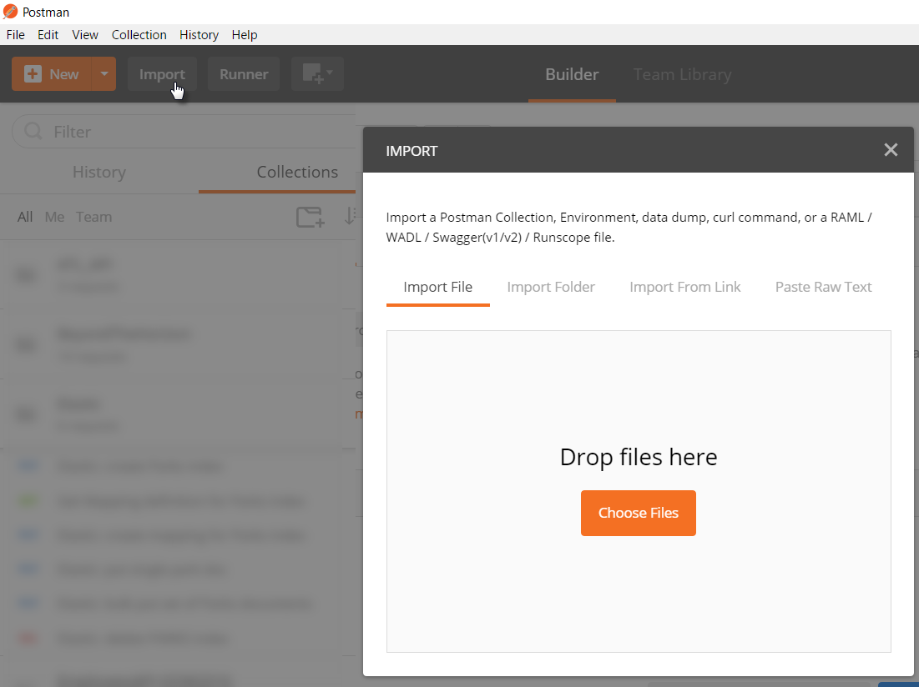

After the import completes, you should see a folder (or collection) called Elastic. It contains definitions for multiple REST API calls to the Elastic Search API.

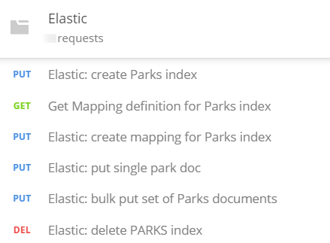

These requests refer to the endpoint of the Elastic Search server you are accessing through an environment variable called {{ELASTIC_HOME}}. Before you can successfully execute these requests, you have to define this variable in an Environment definition in Postman and set its value to whatever the endpoint is in your environment.

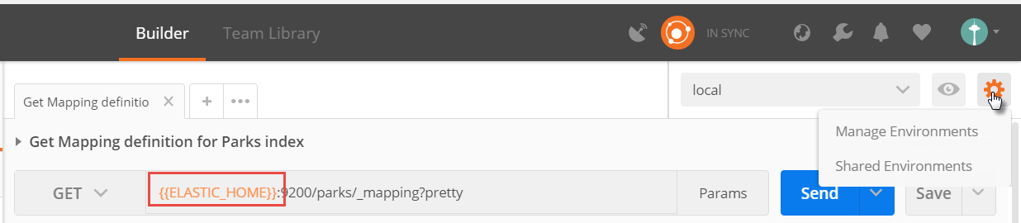

Click on Manage Environments. Then select an existing environment or create a new one. In this environment, define the variable ELASTIC_HOME and set its value according to your local environment:

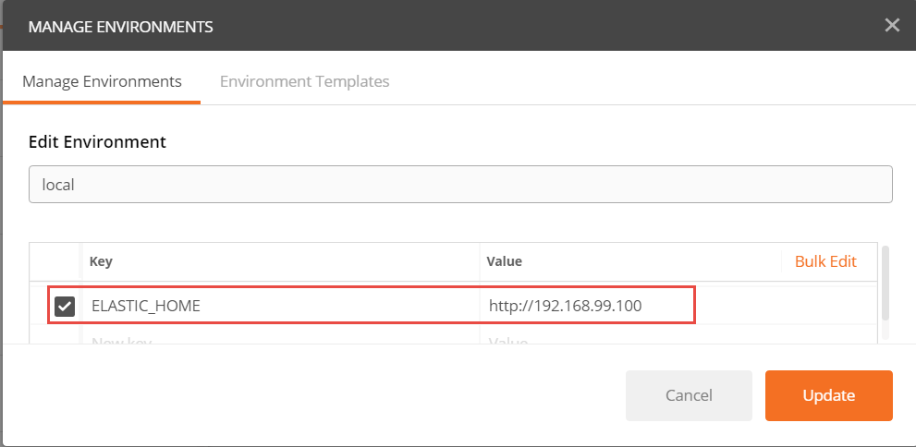

(in my case, I use Docker Quickstart Terminal on Windows. Elastic Search is running in a container inside the Linux Virtual Machine that was setup by Docker Quickstart Terminal to run the Docker Server. This VM is accessed at IP address 192.168.99.100. The container running Elastic Search exposes ports (9200 and 9300) on the Docker Host. These are therefore accessible from the Windows Host machine – where Postman is running – at this IP address.)

To verify the connection, run the Postman Request called *Elastic: check health of server*. Upon a successful response, you can continue. Otherwise you will first have to find out what is wrong and correct it (is the server running did you use the right name for the Postman Environment variable, is the correct environment selected in Postman at the time of making the request, is the IP address used for the ELASTIC_HOME endpoint correct and can you ping that endpoint successfully from the machine where Postman is running?)

## Create the Index and Load the Data

Elastic Search is NoSQL database that allows us to just store JSON document without specifying the structure of those documents in advance. Now that we have a server up and running and we can access it from Postman, nothing is stopping us from loading data into that server and by doing so, creating an index.

Execute the Postman PUT Request *Elastic: bulk put set of Parks documents*. Check the response. It should have response code 200 and contain a logging of all the documents that were created in the index. The data for these documents was in the body of the request. Some 59 documents should be created by this request.

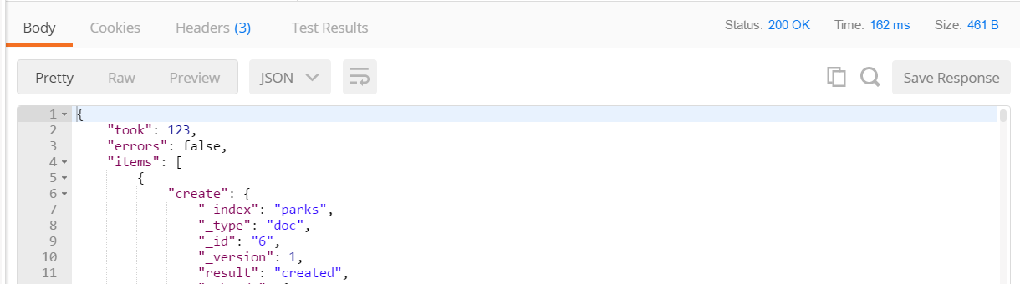

While processing the request, Elastic Search has extracted meta-data about the documents. This meta-data is used for creating inverted indexes that in turn are used during queries.

Execute the request called *Get Mapping definition for Parks index*. The response contains the meta-data that was derived by Elastic Search.

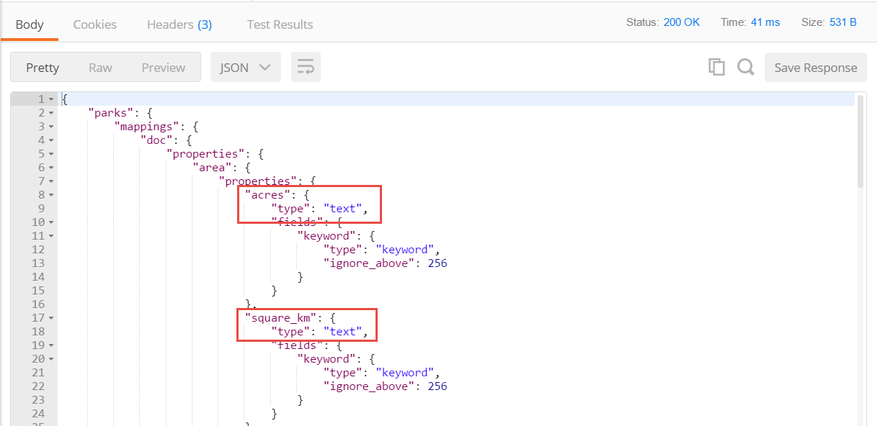

This mapping document tells us about the properties that Elastic Search has identified, the names it will use for these properties and also the type that was assigned to each property. These types determine which operations we can perform on the properties. Numerical properties can be aggregated and used in mathematical operations, but text properties cannot. In the automatically derived mapping document, we can see that properties acres, square_km and visitors have not been identified as numerical. Also the property *date_established_readable* is identified as text – even though we know it to actually contain the textual representation of a date.

Geopoints can be used in geospatial queries. The coordinates property in the national park documents describe a geographical location, but ES has not recognized this property for what it is - but as just a pair of *float* values.

Additionally, some of the text analysis capabilities of Elastic Search depend on the specific language the text is provided in. ES does not derive the language automatically, we have to instruct it when the language is not the default.

In order to fully leverage the querying capabilities of Elastic Search – and the visualization capabilities of Kibana – we should define the mapping definitions for the national park documents ourselves, to help ES do a better job. See the ES documentation on Mapping for more details: <https://www.elastic.co/guide/en/elasticsearch/reference/current/mapping.html> .

We will start from fresh with our index.

Execute Postman request *Elastic: delete PARKS index* to delete the *parks* index. Next, execute request *Elastic: create Parks index*. This creates the index – empty, without data or meta-data.

Now we will add the enriched meta-data – with more instructions for Elastic Search. Execute request *Elastic: create mapping for Parks index*.

Check the body of this request, and find the following refinements:

* Geopoint type for *coordinates*
* Float type for acres and square_km
* Integer type for visitors
* Date type (plus format) for *date_established_readable*
* Type text and fielddata : true for *description*; also: associated custom analyzer std_english with field description (to remove stopwords from this field; see: <https://www.elastic.co/guide/en/elasticsearch/reference/current/configuring-analyzers.html> for details)

Execute request *Elastic: bulk put set of Parks documents* to upload all 59 documents to the index. At this point, Elastic Search has treated the properties in the right way, which will now allow us to query the data in a more meaningful, rich way.

## Query the Data through the REST API

The most simple and straightforward way to retrieve records from an Elastic Search index is using a simple GET request, as is shown in Postman Request *Query for all parks*. This is a simple GET request to the _search operation on the index:

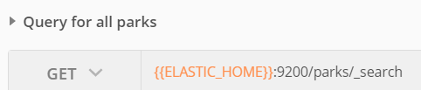

This simply returns all National Park Records from the index, with all fields, no scores or sorting.

### Sorting, Batching and Focusing

The Postman Request *Query for all parks - sorted on world heritage site and number of visitors* shows how the query result can be in the request. Specifically, it shows how the sorting of the returned records is indicated, how the size (and start point) of the returned set is determined and how the fields returned in the result can be selected:

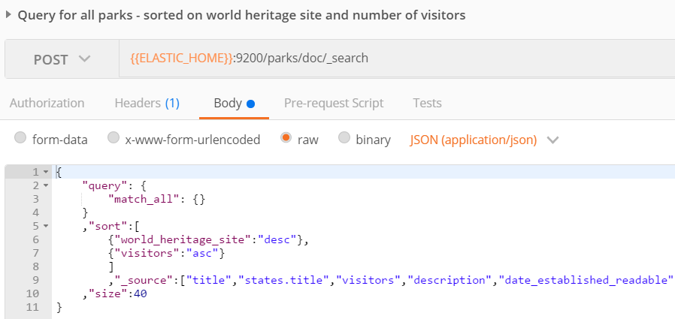

### Use wildcards in Queries

In Postman request *Query Parks - in a state whose name starts with M* the query is on property states.title. In this case we want to retrieve all parks who are in a state whose title starts with an M. The wild card character * is used, to indicate that the M can be followed by any sequence of characters.

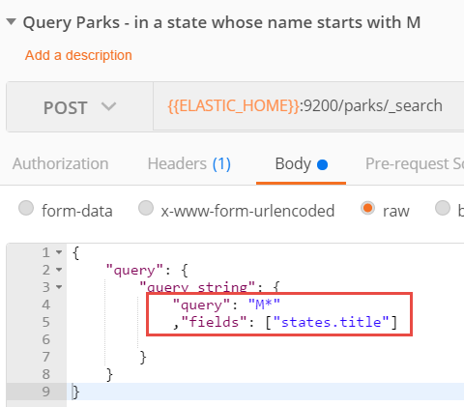

See the ES for details on wildcards in queries: <https://www.elastic.co/guide/en/elasticsearch/reference/current/query-dsl-wildcard-query.html> .

### Sort records on Geospatial attributes

Elastic Search is aware of geo-spatial properties and leverage that awareness in search operations. One example is seen in Postman request *Query Parks - sort for distance from New York*. Here parks are sorted based on their distance to New York City (whose coordinates are 40.7 (latitude) and -74 (longitude).

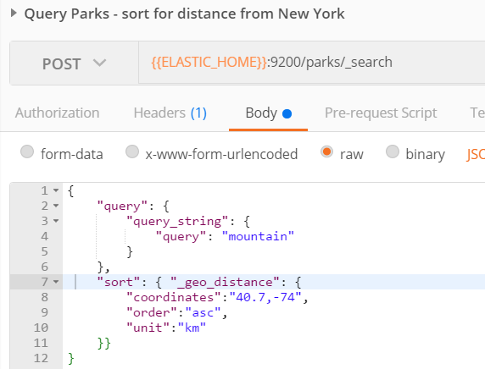

### Score records on a simple search term

The Postman Request *Query Parks - that contain Mountain* performs a simple query. It search parks for the word “mountain”. It takes all properties into account. It will calculate a score for all records, based on the presence of contents that match – a little or very much – on that term.

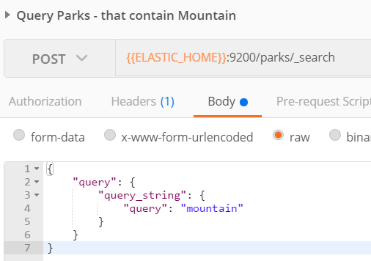

### Combine scored condition with absolute filters

A query can contain both absolute filters conditions – that determine if records can be part of the result set at all – and criteria that enhance the score when matched, but are not a hard prerequisite.

The query in request *Query and Filter Parks - that ideally contain Mountain and are a World Heritage Site for sure* has a combination of these two types of conditions:

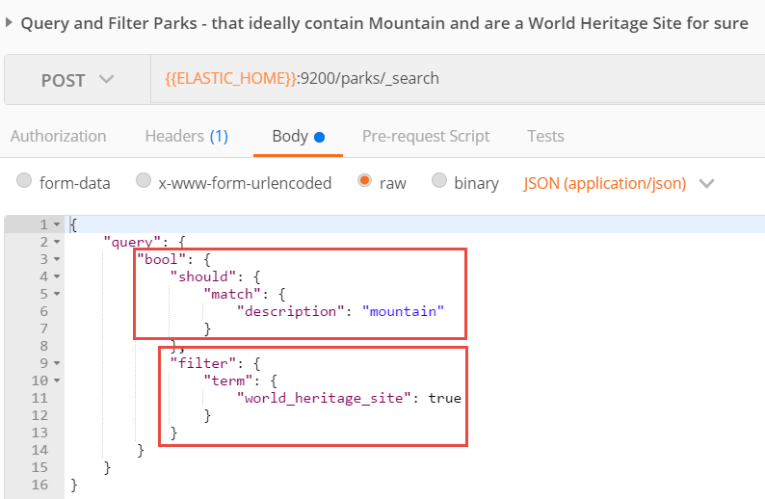

This request returns only parks who are a world heritage site. These parks are score based on whether their description contains mountain (a lot).

### Highlighting and Query Explanation

Elastic Search search results can be enriched in several ways. One is by explicitly highlighting the terms that were matched and the sentences that contained them. Another is by explaining how the search result was arrived at.

Execute this Postman Request:

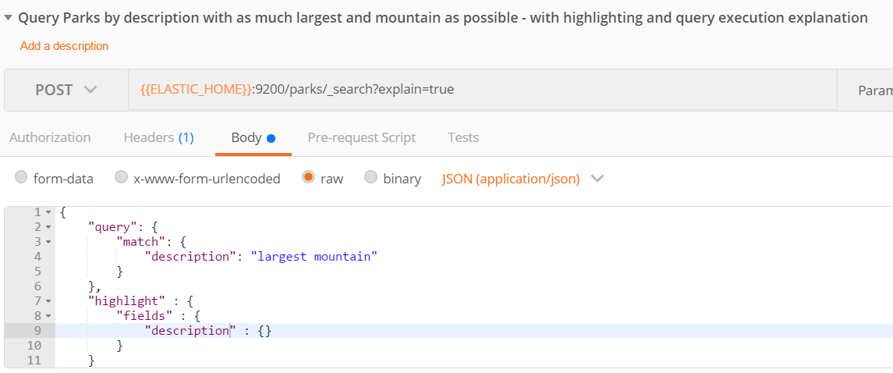

The results will contain both the result highlighting and the query explanation. Remove the URL query parameter *explain* to return to a simpler result set.

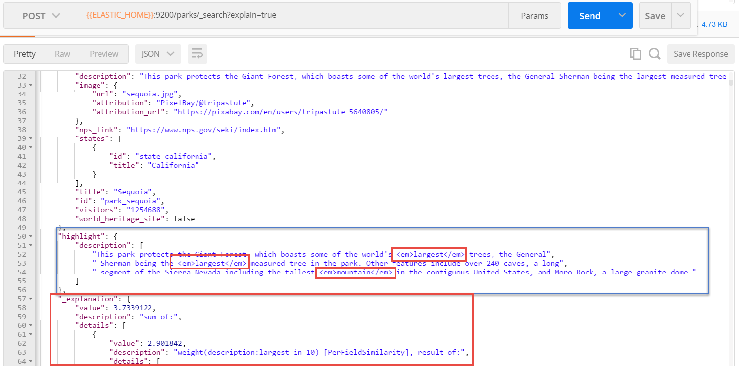

### Queries through GET requests and URL parameters

Complex queries can be performed using GET requests by stuffing all search instructions in the URL. See the Postman Query *Query Parks - fuzzy, proximity - with query execution explanation*

{{ELASTIC_HOME}}:9200/parks/_search?q=description%3Amountaon~2+visitors%3A<1000000+!(states.title%3AAlaska)&default_operator=AND

and execute it. It returns: parks that have the string "mountaon" in their description - or something that is close to it (our fuzziness allows for up to two character edits distance); we also require (note how the default-operator is explicitly set to AND) the number of visitors to be under 1 Million and these parks are not located in Alaska.

This article describes in a lot of detail how the ES queries through the URL GET interface are constructed: <https://www.compose.com/articles/using-query-string-queries-in-elasticsearch/> Tip: URL Encoding: <https://www.w3schools.com/tags/ref_urlencode.asp> describes how to encode characters such as : (to %3A)

## Use Kibana to Explore the Data

Open Kibana – probably at port 5601 at the same (Docker) host that is running Elastic Search. For me the endpoint is:

<http://192.168.99.100:5601>

Kibana has to be connected a to an Elastic Search Index, in order to explore data. When the Kibana container was started, it was already configured to connect to the Elastic Search Server. Now we need to provide the name – or pattern – of an Index on that server.

Type *parks* or *park\** to focus Kibana on the National Parks index.

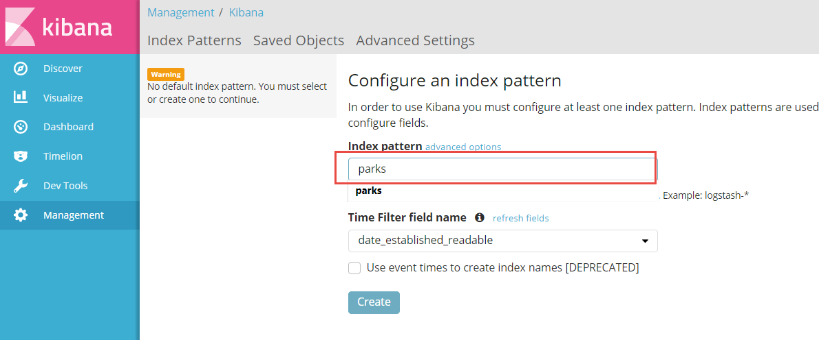

In the dropdown box for Time Filter field name, select the option *I don’t want to use the Time Filter*. This option is primarily useful with data that continuously streams in, like log file entries, IoT events and web site click actions.

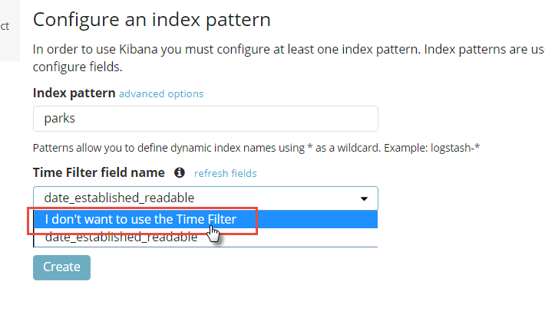

Next, click on the Create button:

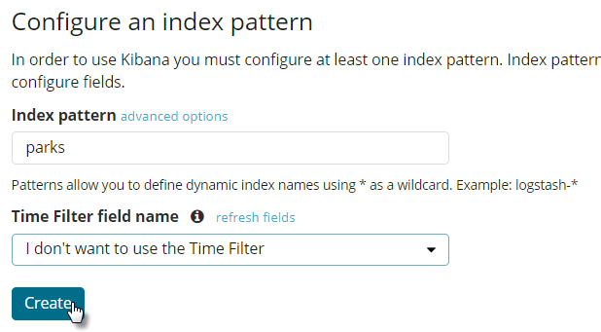

Kibana reads the meta-data for the index and configures its own representation, that is shown next:

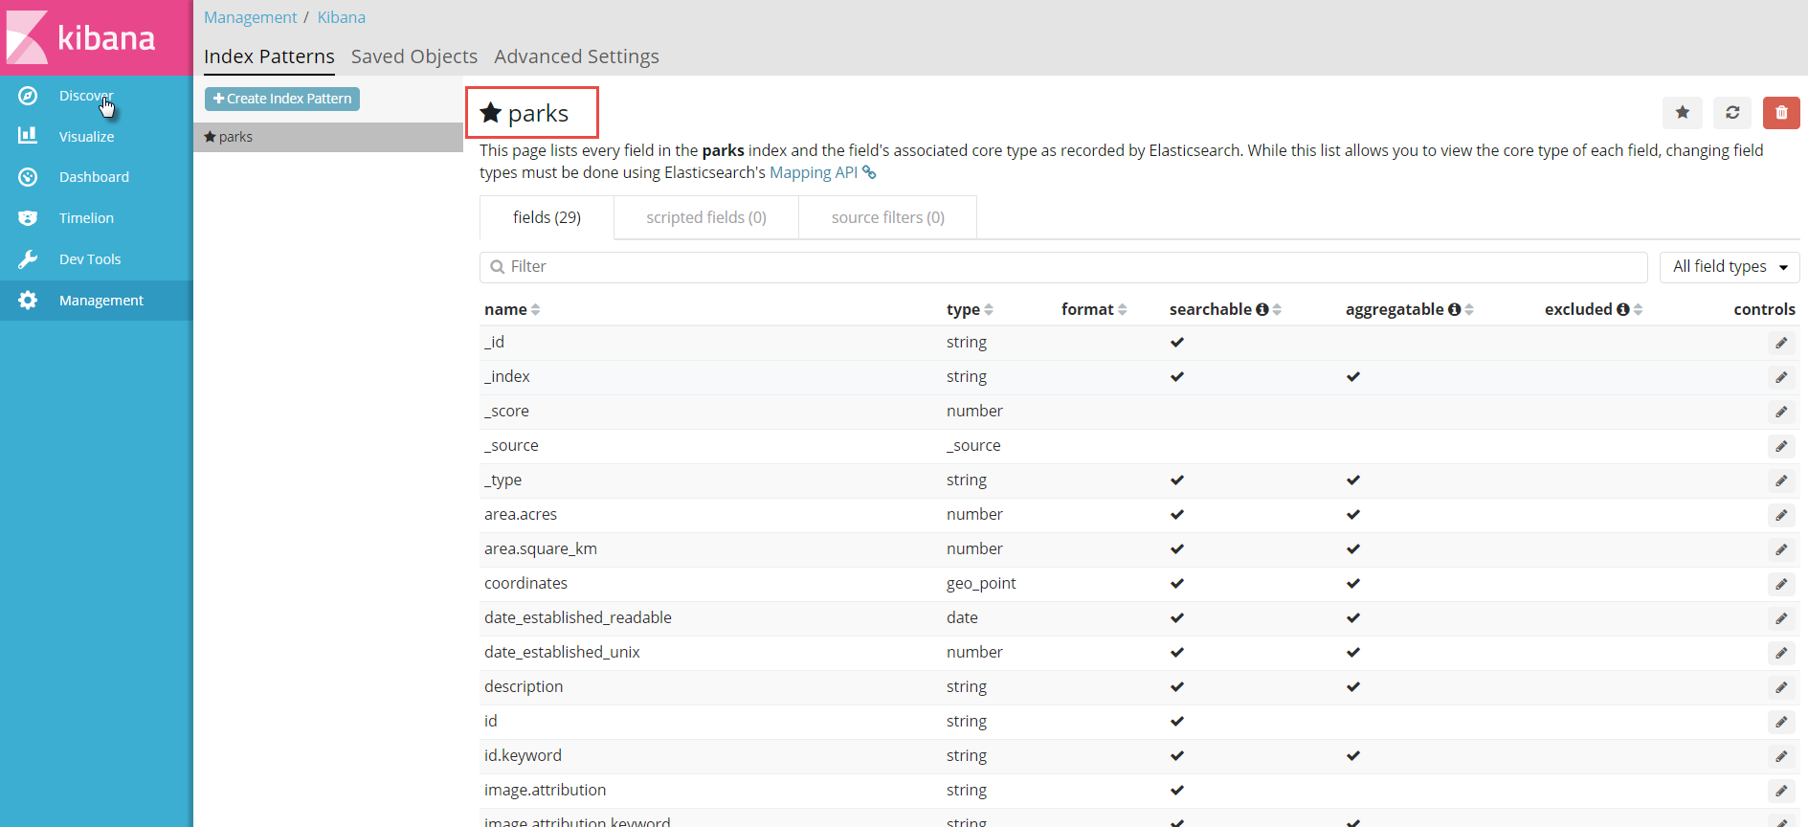

Click on the option *Discover* in the upper left hand corner.

This brings a page where you search, filter, explore the data in the index, using the same search facilities we have seen in the REST APIs.

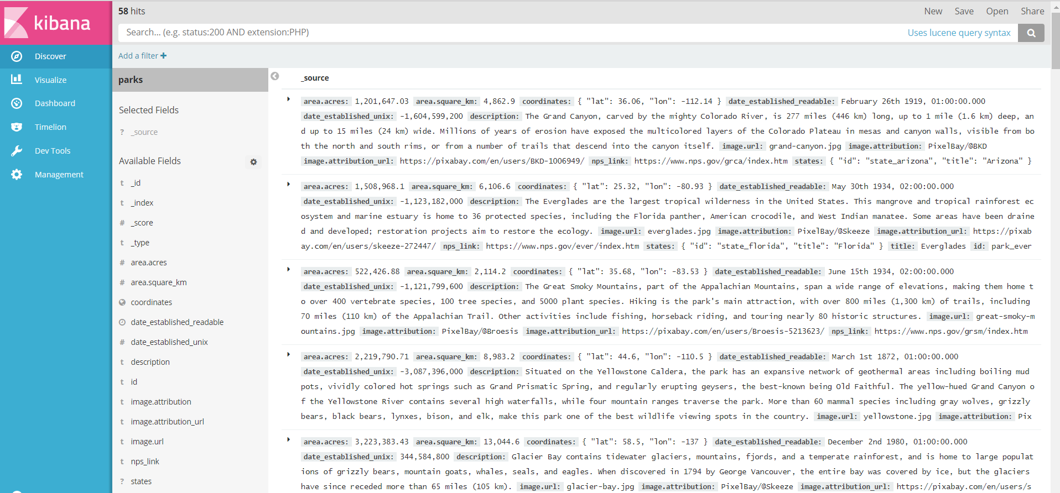

For example: type the following search string in the search bar and press enter or click on the magnifying class:

states.title:"Alaska" AND visitors:[500000 TO 600000] AND description:"mountain"

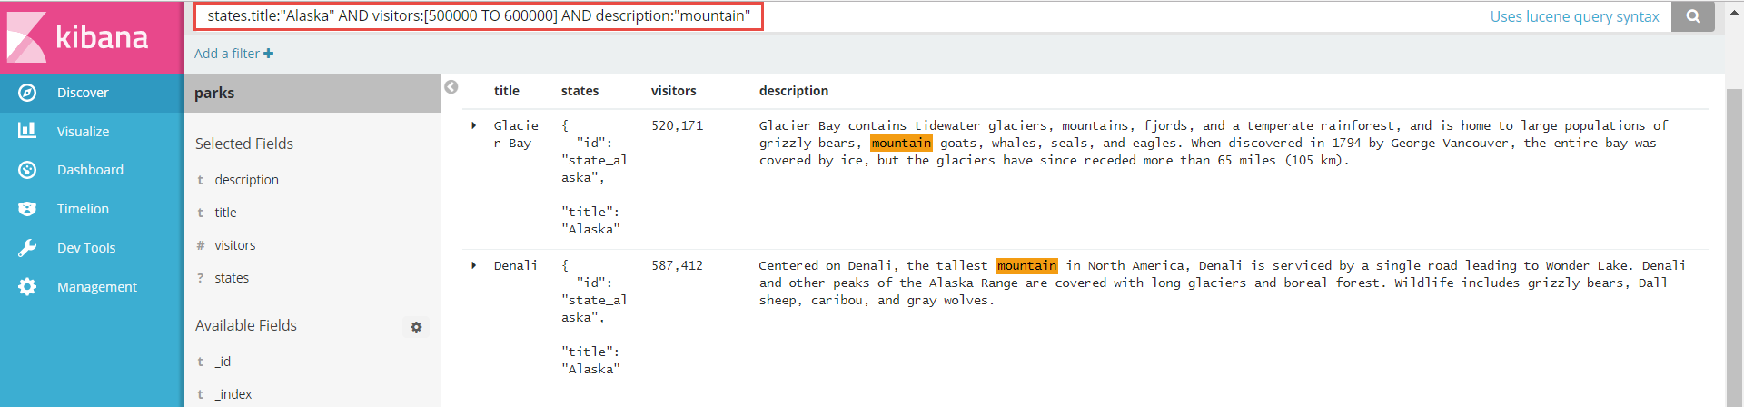

The results of executing this query are shown.

Note: feel free to experiment with the query – by changing the search conditions and the properties that are searched on.

For example: find all parks that are within 1000 km from San Francisco and that have forest or trees mentioned in their description:

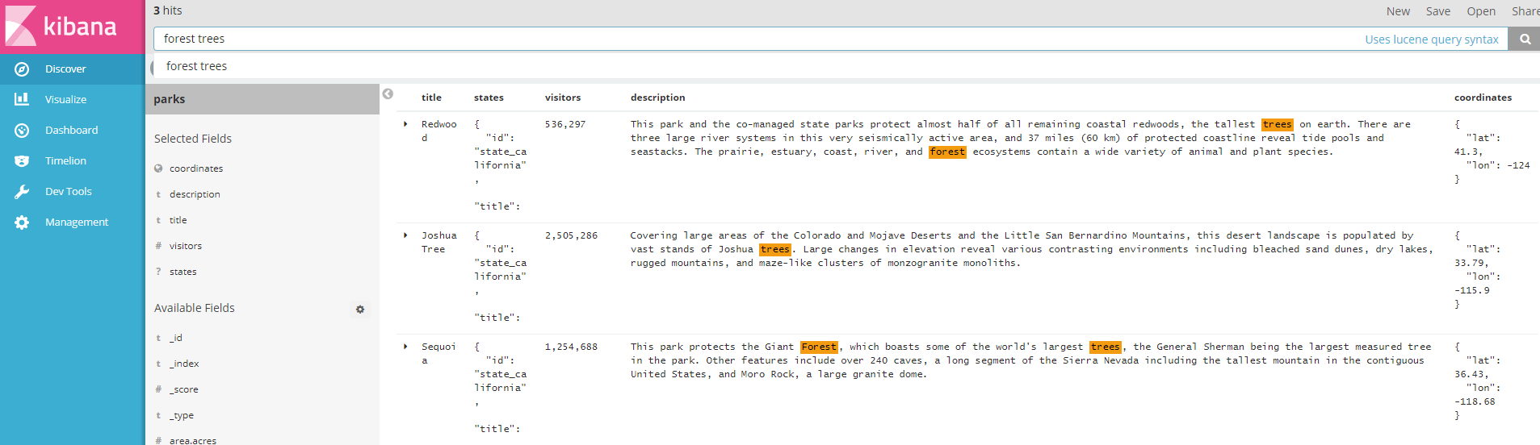

Note: the geospatial query used here:

{

"query": {

"bool": {

"must": {

"match_all": {}

},

"filter": {

"geo_distance": {

"distance": "1000km",

"coordinates": {

"lat": 37.7,

"lon": -122.4

}

}

}

}

}

}

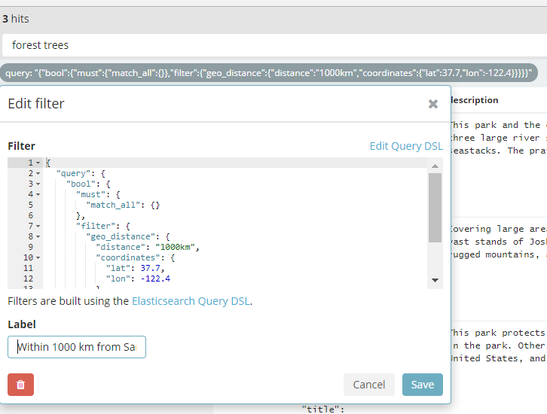

Note: you can use the option *Share* in the upper right hand corner to get a URL that when clicked will navigate the browser immediately to the Kibana data discovery page with this same query executed (and possibly different results depending on what data was added, changed and deleted from the index)

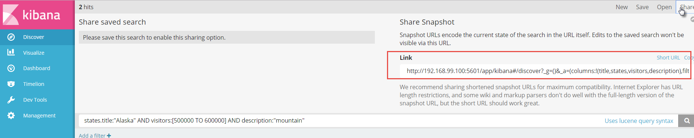

### Visualizations

One of the very powerful capabilities of Kibana is the creation of data visualizations. Kibana understands Elastic Search and the meta data for the Elastic Search Indexes. It can use this understanding to help very quickly create relevant visualizations, such as a map for geospatial data, a timeline for date and time related data and various type of charts for numerical, clustered data.

Click on Visualize in the left column. Then click on the Plus icon to create a new visualization.

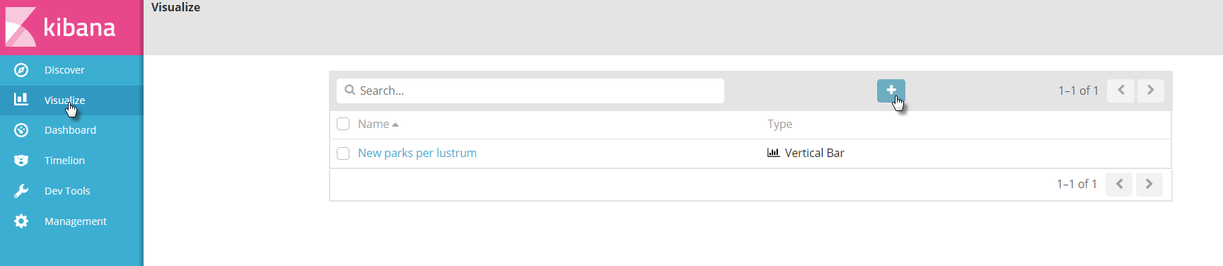

#### Nested Pie chart (aka Sunburst) – Comparing size of Parks by and within States

Select the Pie Chart visualization type:

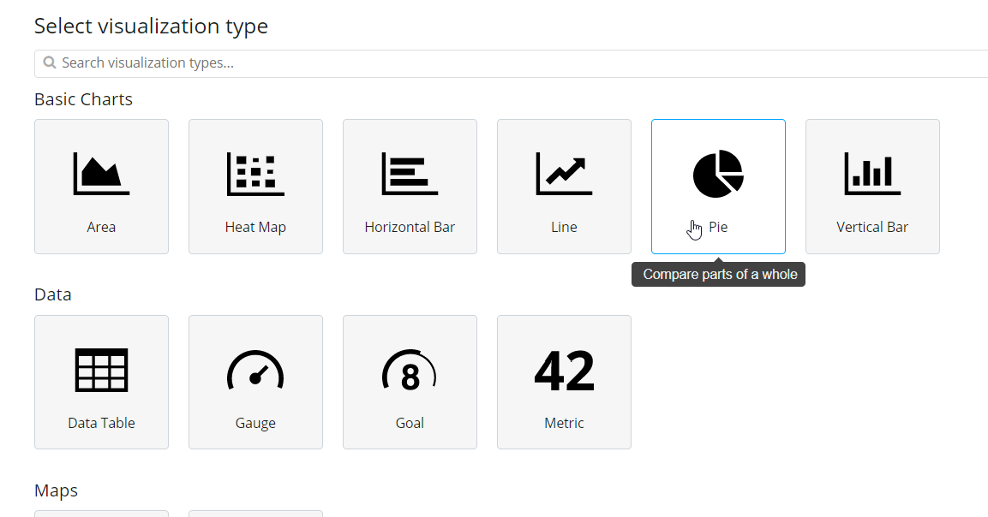

Select the index *parts* as the data source for the visualization:

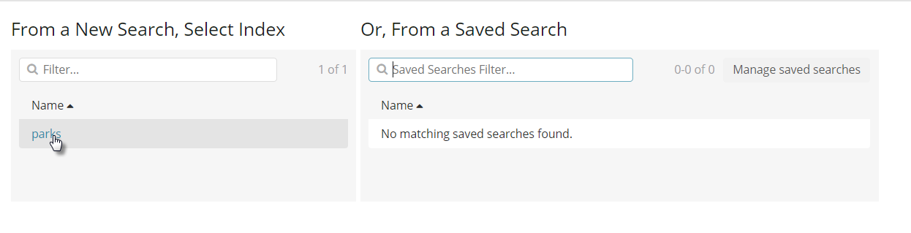

Click on the expand icon for Slice Size – to define the pie segments:

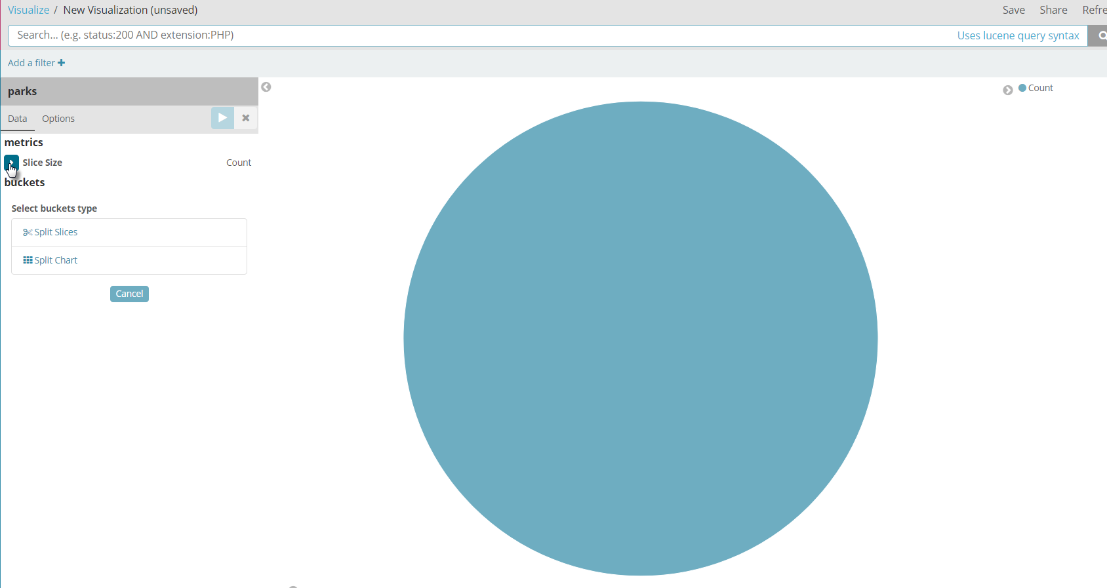

Specify Sum as the type of aggregation, select field area.acres and set Area as the custom label.

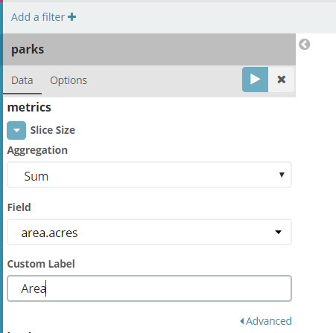

Next, click on Split Slices

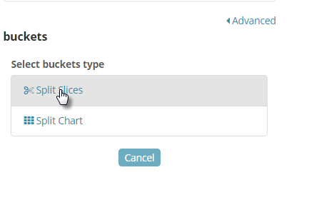

Time to define the clustering – what are the slices aggregated on.

We will have to levels of slices. The first is parks grouped by state. Select *Terms* as the type of aggregation. Select states.title.keyword as the field and metric: Area for order by. Set the size to 10 (meaning: include the 10 largest slices) and type *State* as the custom label:

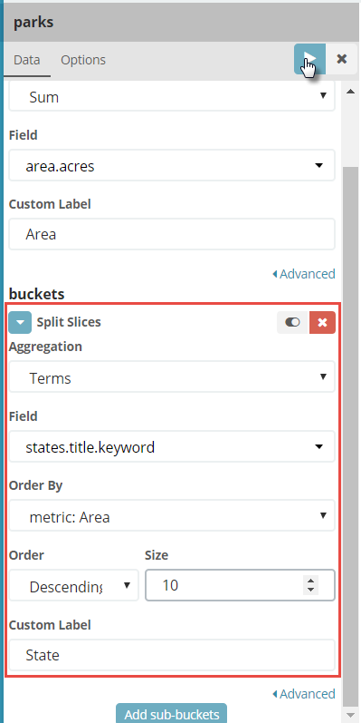

Click on the run icon in the top right hand corner of this panel. This will render the Pie Chart based on these definitions for all records in the *parks* index – since we did not define a search condition.

This is what the chart looks like:

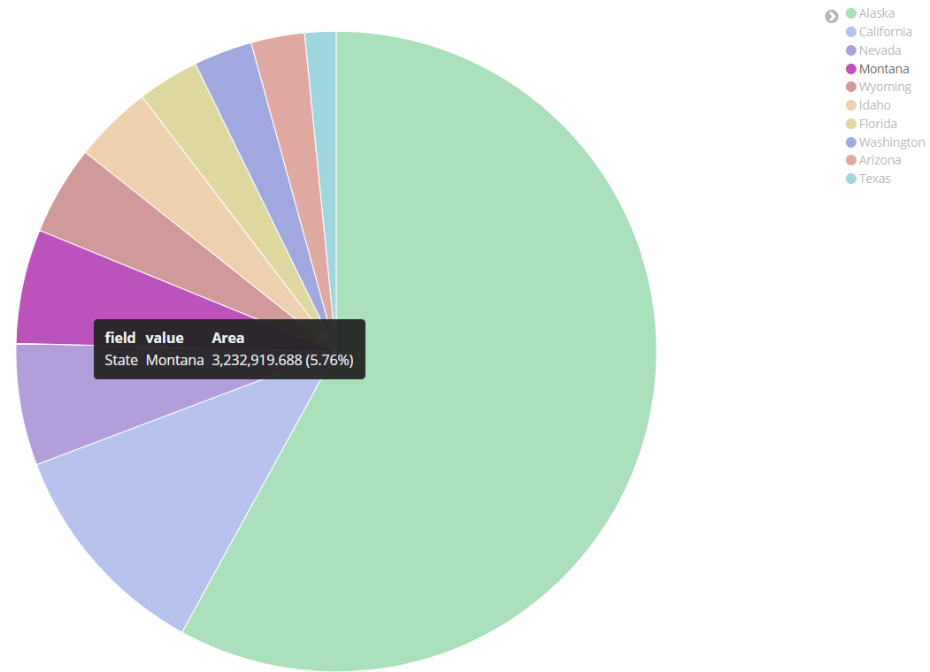

Now we will add a second level.

Click on the button *Add sub-buckets*:



Now define the slices for this second level – the level of the park [within the state].

Click on Split Slices:

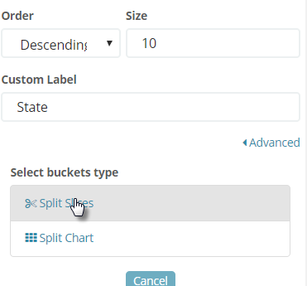

and define these settings:

* Aggregation [Type]: terms
* Field: title.keyword
* Order by: metric: Area
* Size: 7
* Custom Label: Park

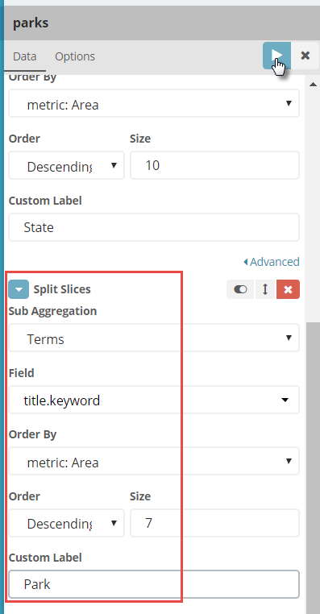

Then click on the run button to render the chart based on these extended definitions:

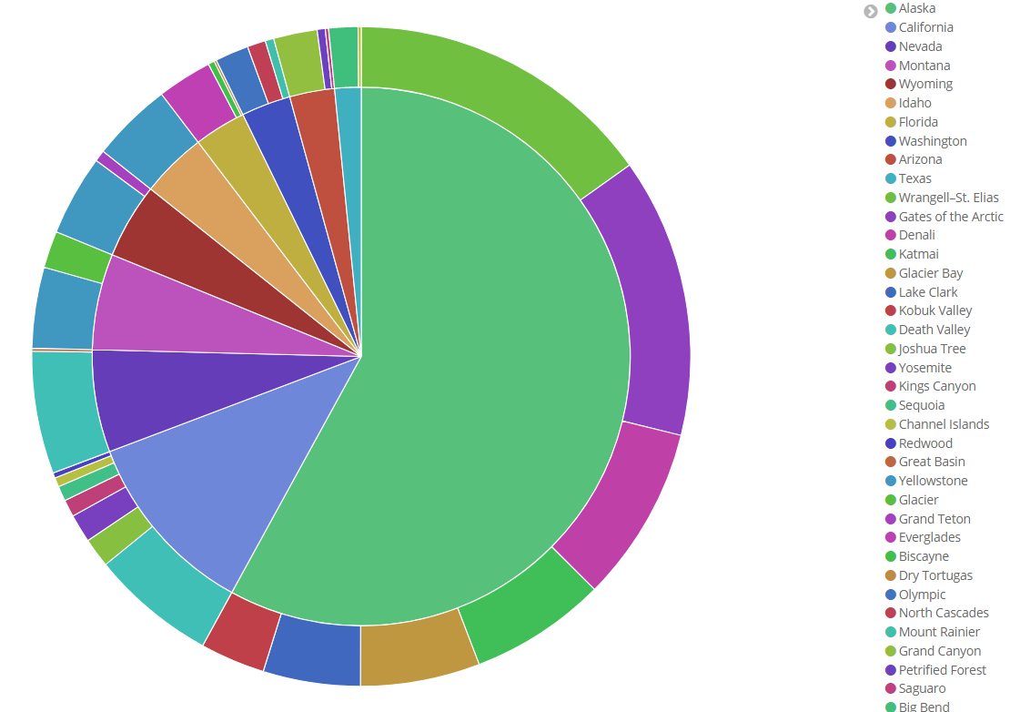

The second ring shows the sizes of the individual parks and tells us how the total area of a state is distributed over its parks.

In case you are wondering what the biggest park in California is – the next figure will tell you.

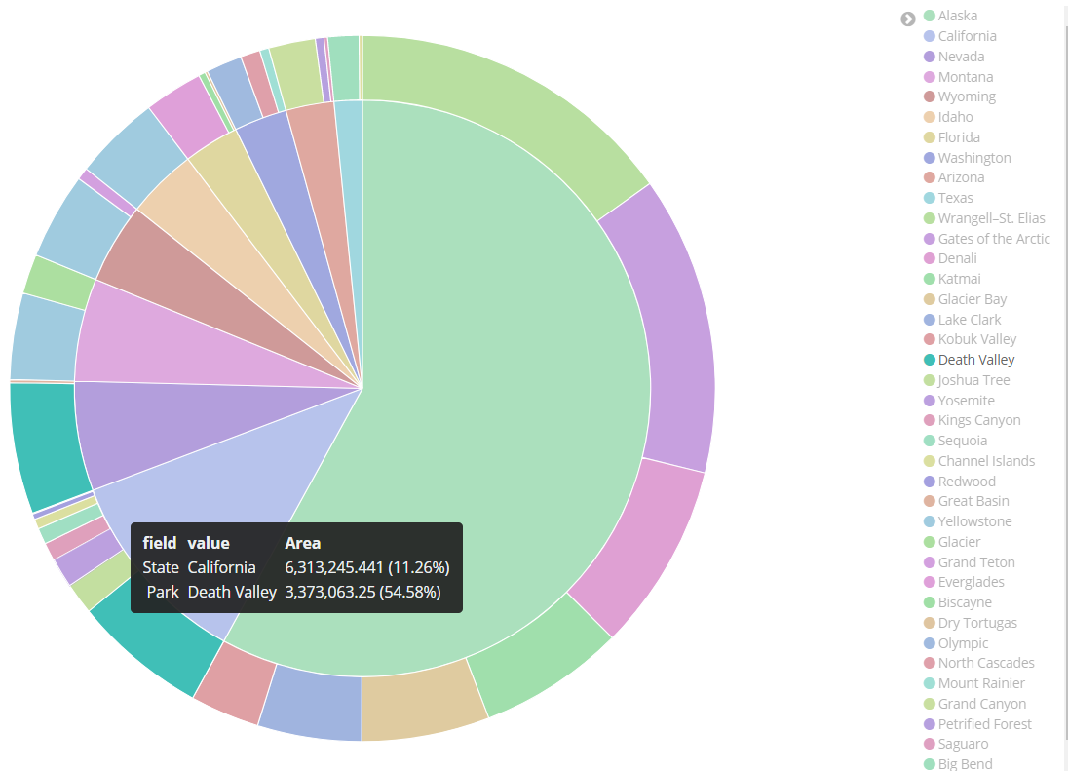

Click on the Save option in the upper right hand corner. Save the Visualization as *Park Area Pie*.

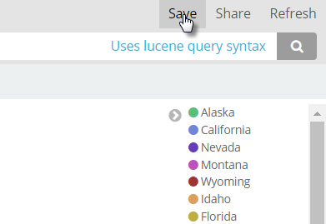

#### Tagcloud with States

Our objective: show in a tag cloud the names of the states with the biggest national parks areas – using the tag sizes to indicate the relative area sizes.

Create a new visualization, of type Tag Cloud.

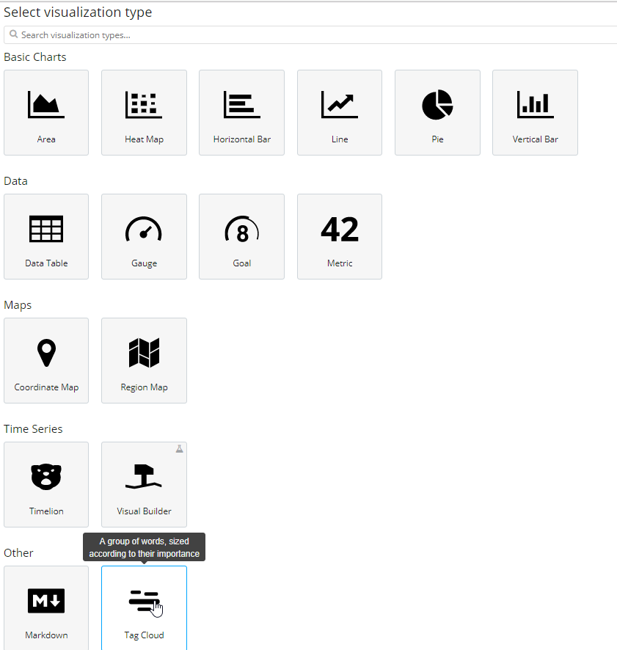

Select the *parks* index as the data source.

Define the tag size:

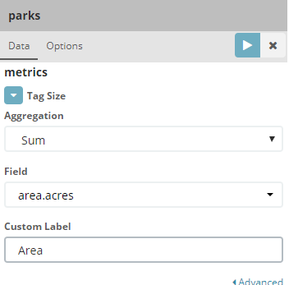

Next define the *buckets* (the aggregation grouping).

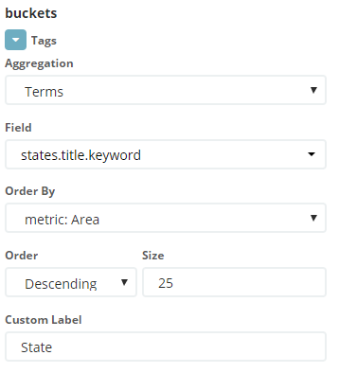

If you open the *Advanced* section under *buckets*, you can specify an include (whitelist) or exclude (blacklist) set of tags for the cloud.

Click on the run (or render) icon to display the tag cloud:

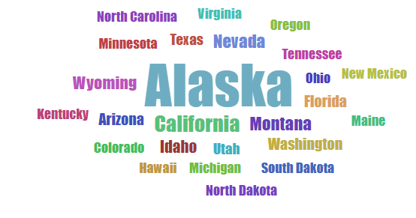

The options panel allows you to fiddle with the font size, the text orientation and scaling algorithm.

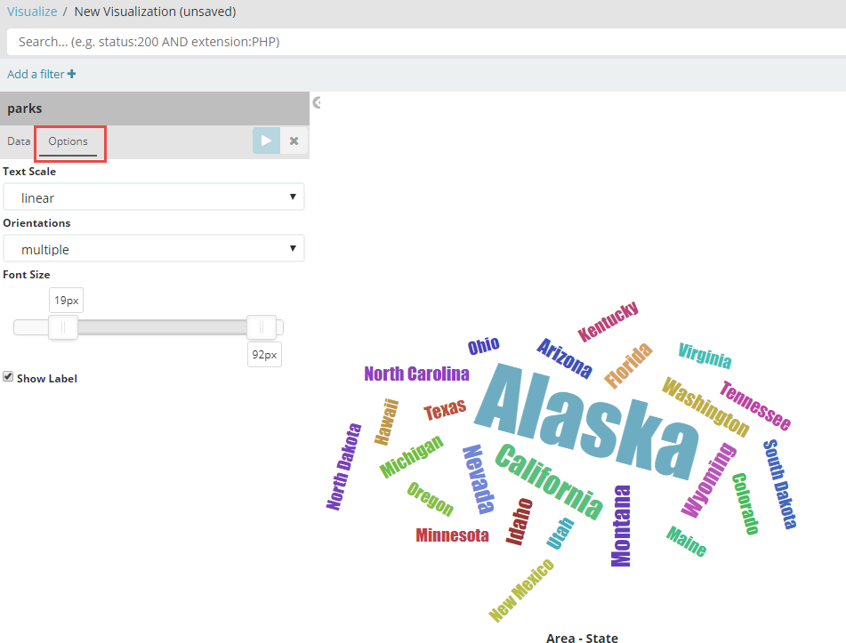

Save this visualization as State Tag Cloud.

#### Tagcloud with terms from description

Create a new visualization. Choose Tag Cloud as the type. And *parks* as the index to fetch the data from. Define the metrics – Count as Aggregation type – and buckets – Terms for Aggregation, description for field, Order By: the metric [Number of Occurrences] and Descending. Important: use the Exclude property to filter out keywords that are not in the Stoplist for standard English, but that are meaningless for our purposes. For example:

also|than|km|over|has|its|more|from|which|including|well|other|covered|area

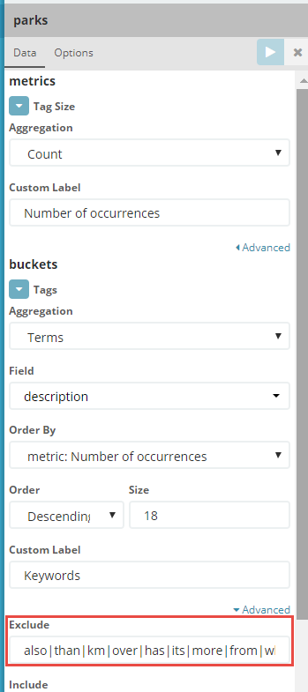

Press the Run icon to render the tag cloud:

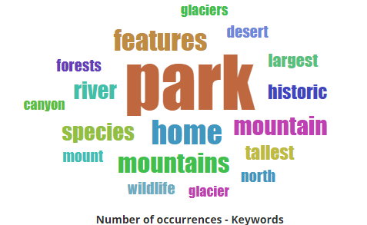

Note: by clicking on tags, you add them as filter. This means that the tag cloud is recreated - based only on those national parks that have the selected terms in their description. Here I have clicked on *river* and subsequently on *bison*.

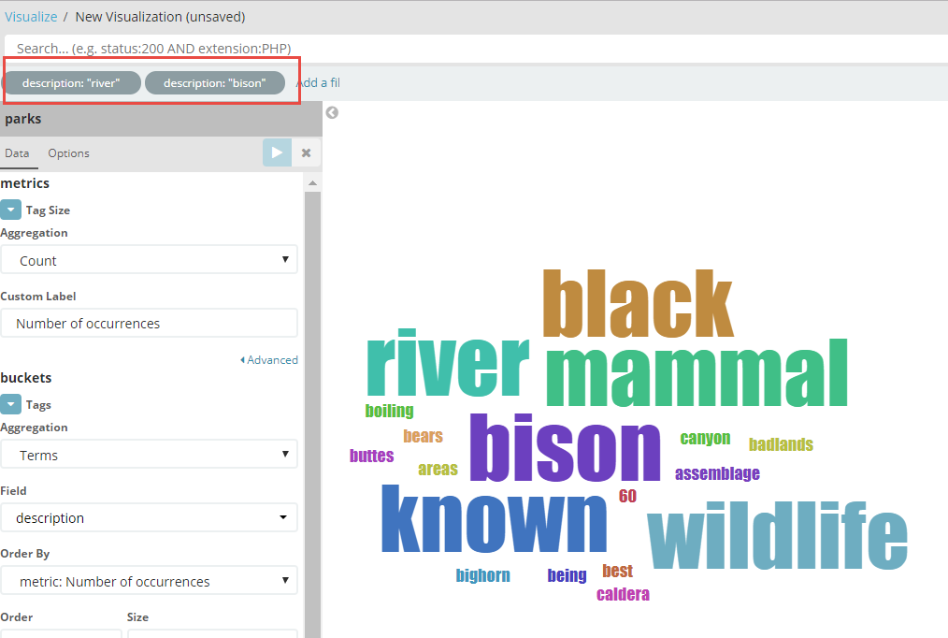

Save the visualization as *Descriptive Tag Cloud*.

#### Map with all national parks

The park records have geopoints associated with them that describe their geographical location. Let’s visualize the parks on a real geographical map.

Create a new visualization. Choose Coordinate Map as the type. And *parks* as the index to fetch the data from.

Configure the visualization like this:

* Metrics
  + Aggregation: Count
  + Custom Label: Number of Parks
* Buckets
  + Aggregation: Geohash (preselected)
  + Field: Coordinates (the only one in the index of type Geopoint)
  + Custom Label: National Park

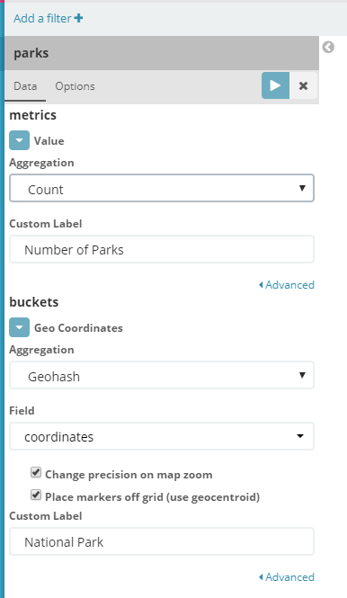

Click on the run icon to render the map.

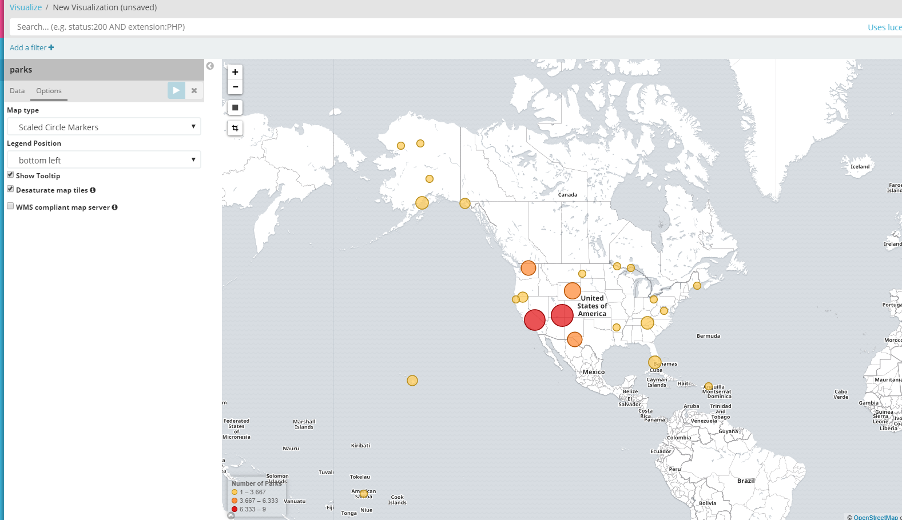

The size and colors of the markers indicate the number of parks in the vicinity. When the mouse hovers over the markers, details are shown:

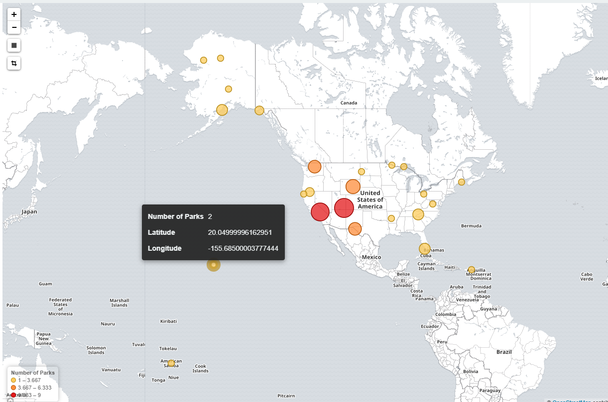

When you zoom in, the area over which aggregation of the park count takes place is reduced in size. Only two clusters of two “twin-parks” remain:

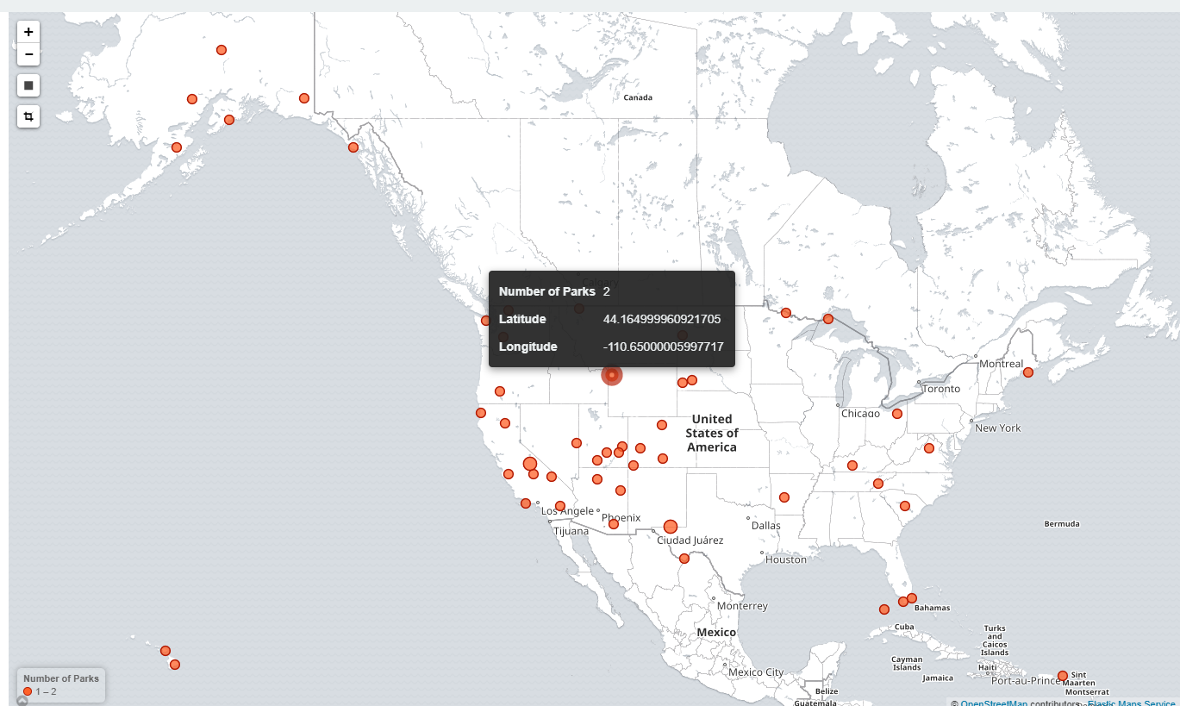

Save this visualization as *Map of Parks*.

#### Date Histogram with History of Park Establishment

Some of the national parks are quite old while others have been established fairly recently. We will now take a look at when the parks were formally opened – to see in which time frame in last 150 years there were ups and downs in this process.

Create a new visualization. Select Vertical Bars as the visualization type. Select *parks* as the data source.

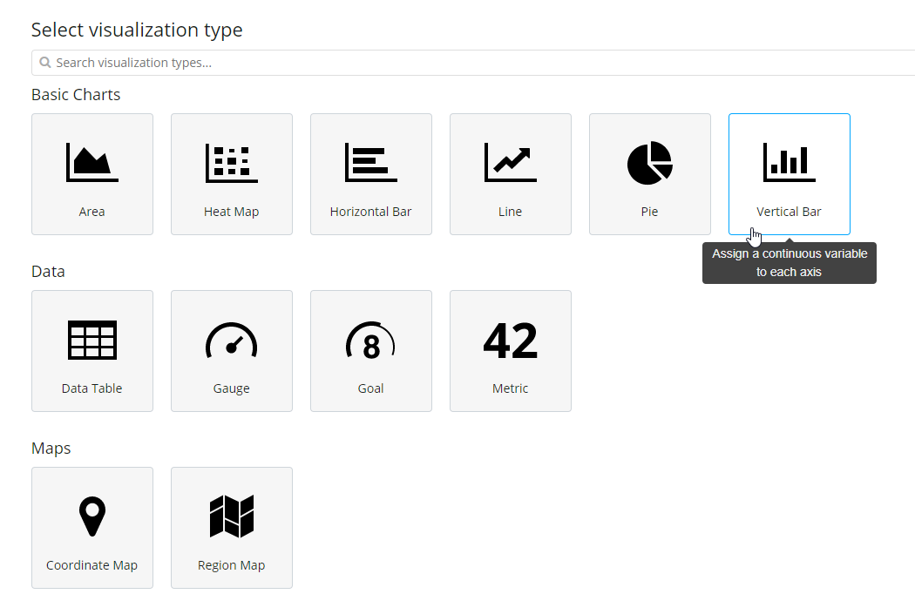

Click on X-axis as bucket type:

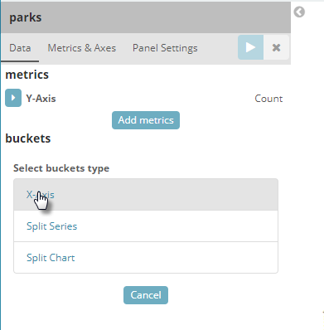

Select Data Histogram for Aggregation:

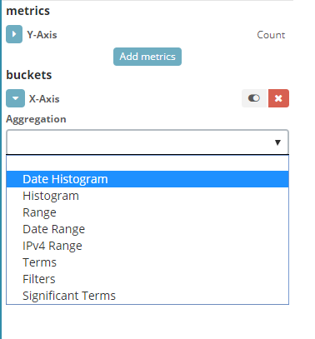

Specify these settings for Field, Interval and Custom Label:

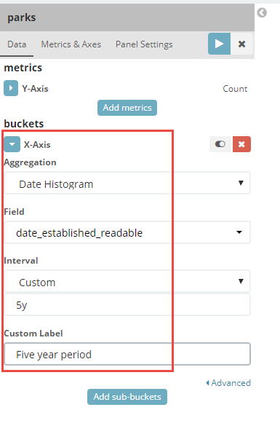

Define the Y-axis metric:

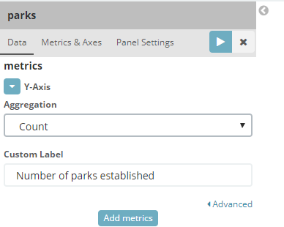

And press the run icon:

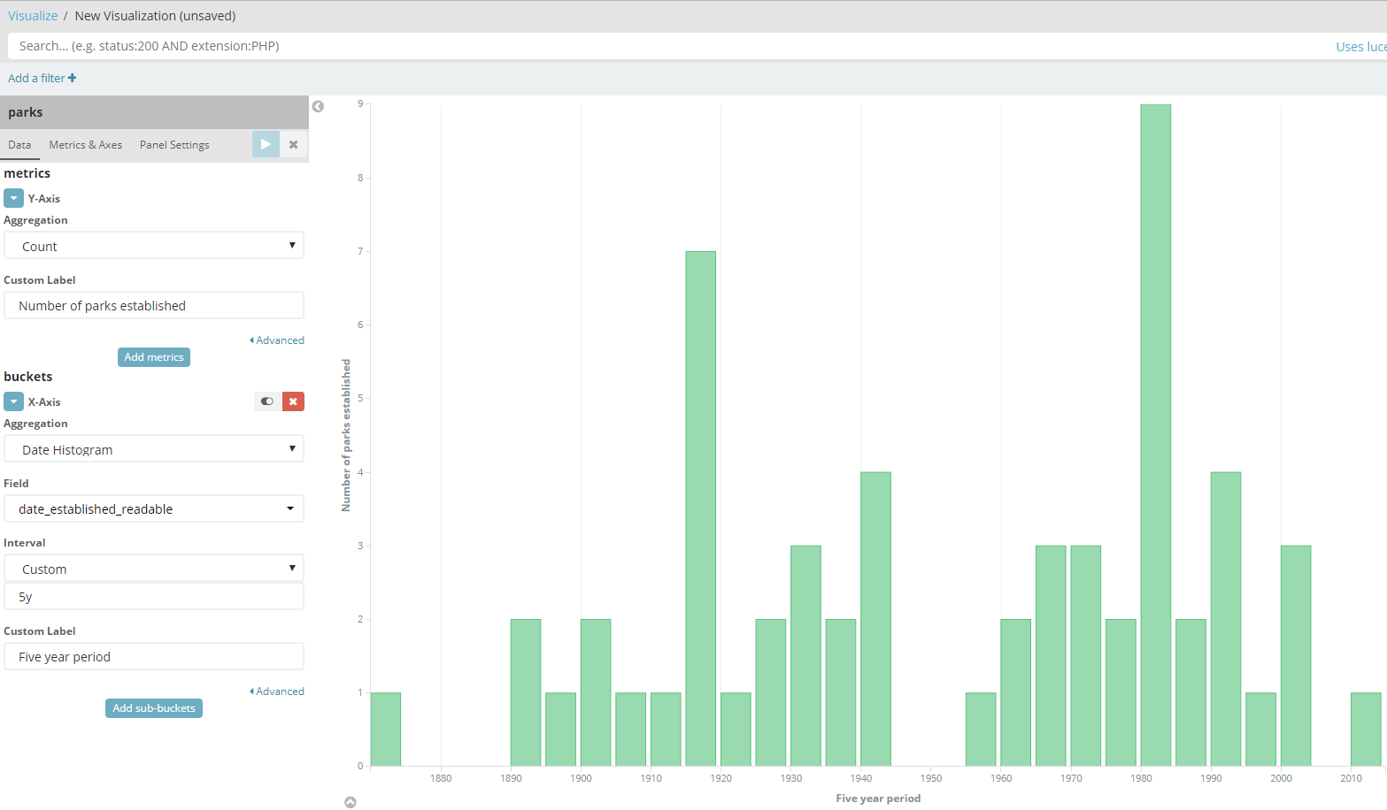

The gaps are clear – especially the one between 1945-1955. The peaks are somewhat remarkable, especially the highest one.

Let’s visualize in which states these parks were established. Click on Add sub-buckets and specify the Spit-Series properties as shown here.

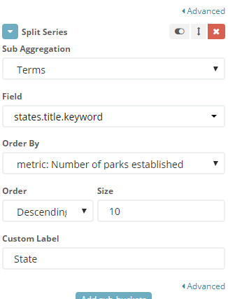

Run the visualization again:

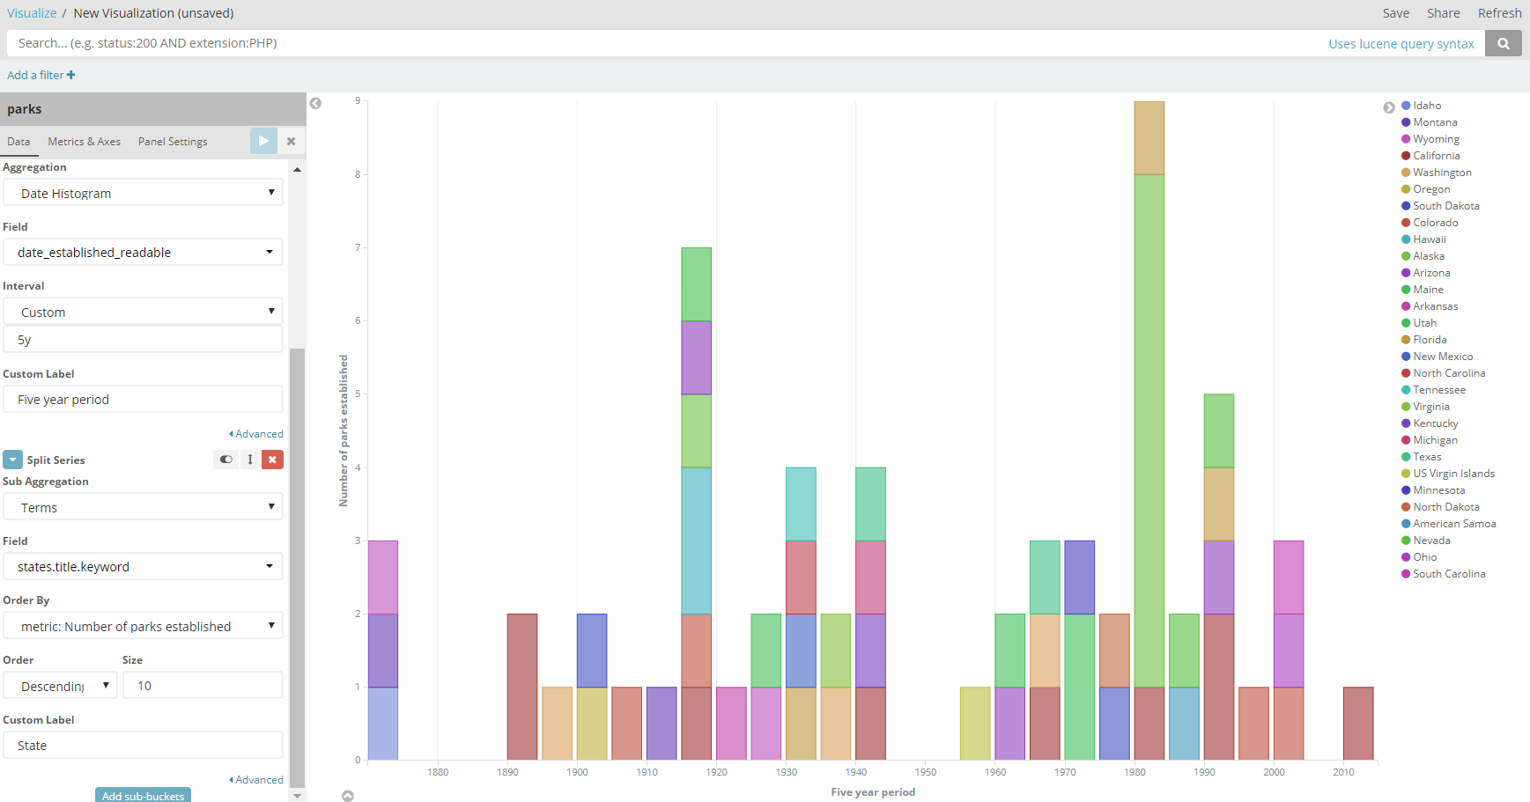

Hover over a bar segment to learn more about it:

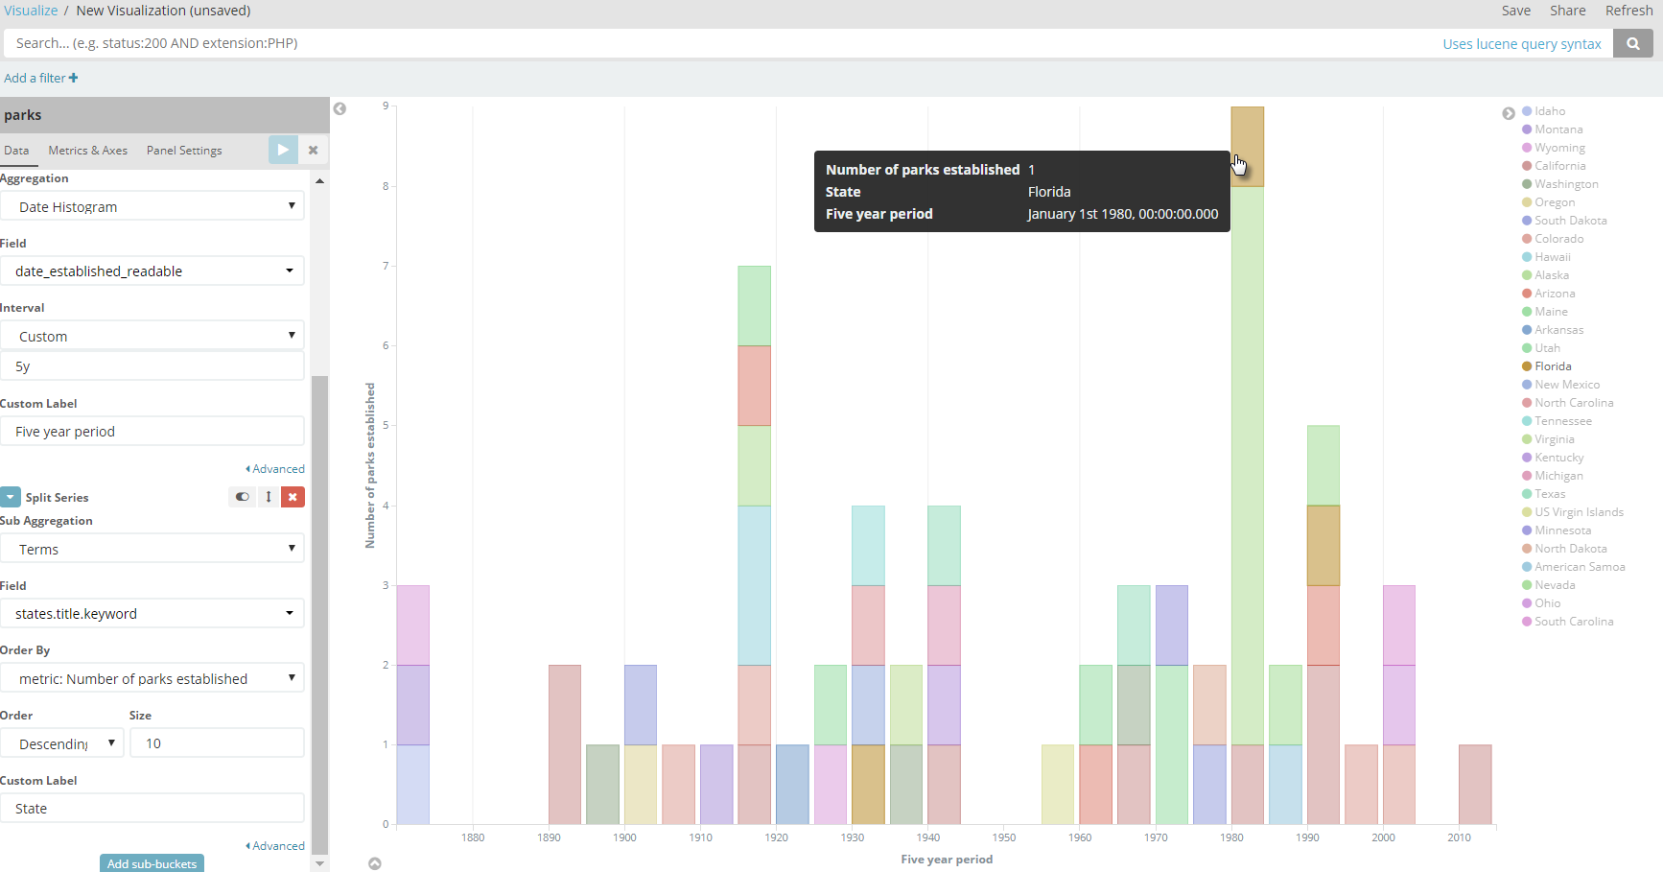

Click on it to turn it into a filter. Here, we click on a segment for Florida.

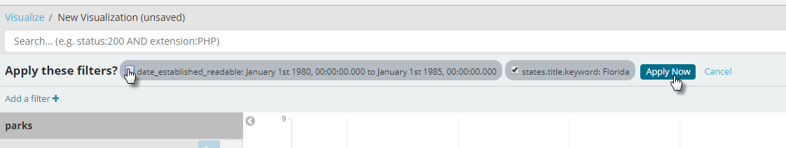

A filter is created for this time period and this state. Uncheck the time related filter condition. Then click on Apply Now to filter the source data on the state of Florida. This allows us to quickly zoom in on the creation of the national parks in this particular state:

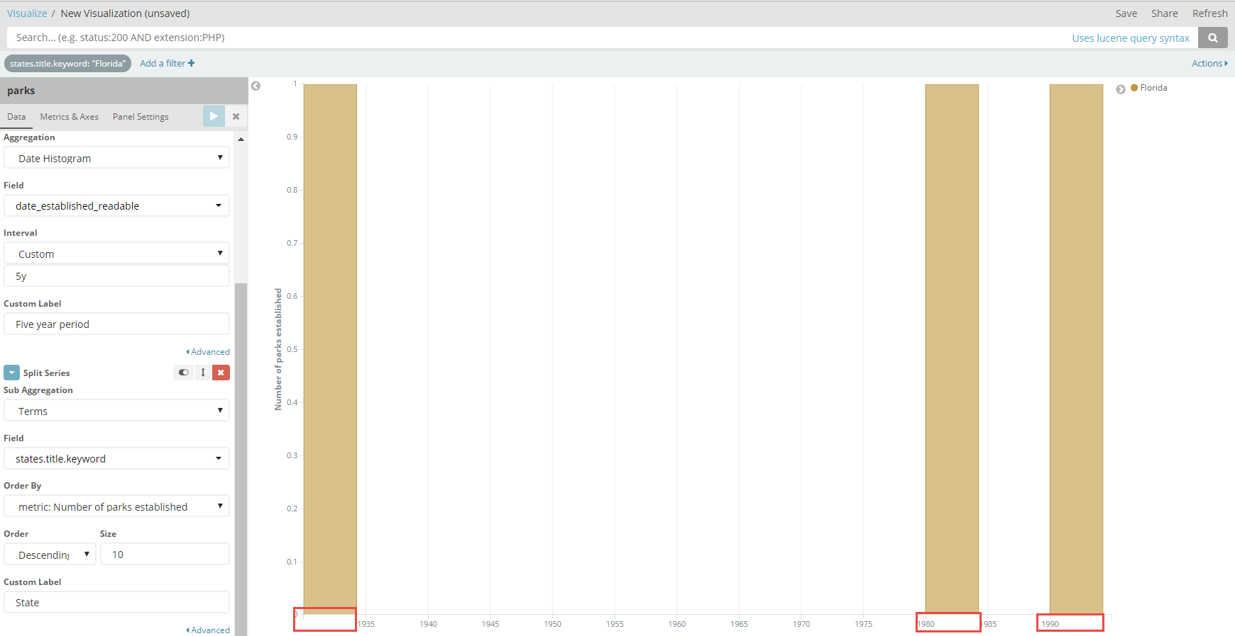

Save the visualization as *Parks Creation History*.

### Dashboard

Click on Dashboard.

Click on Create a dashboard.

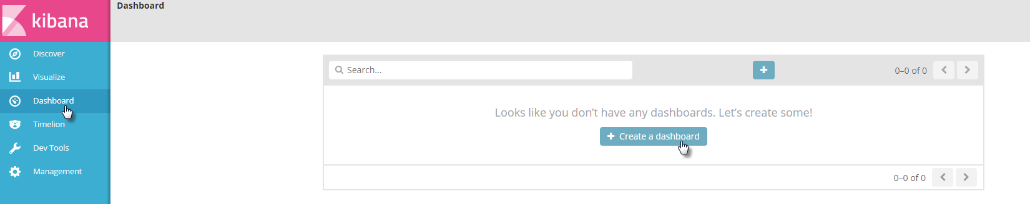

Click on



A list of Visualizations is presented. Click on *Map of Parks* to add the map as first visualization to the Dashboard:

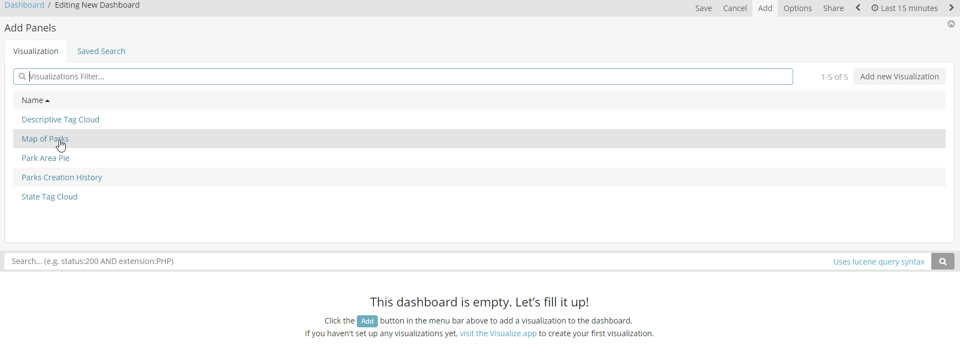

The result:

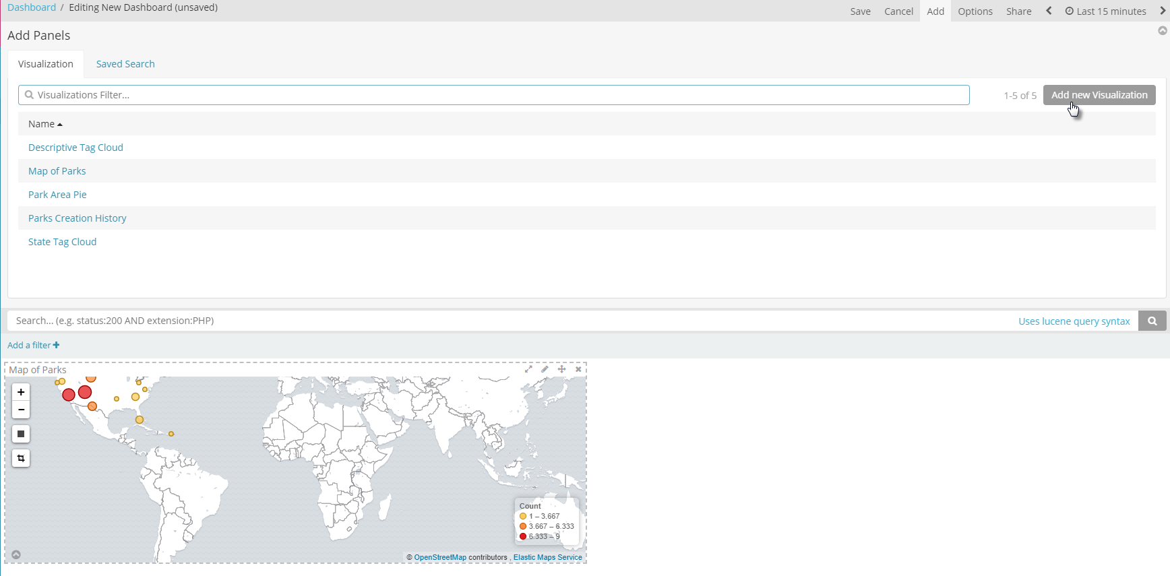Click on the button *Add new Visualization* and add all visualizations to the dashboard.

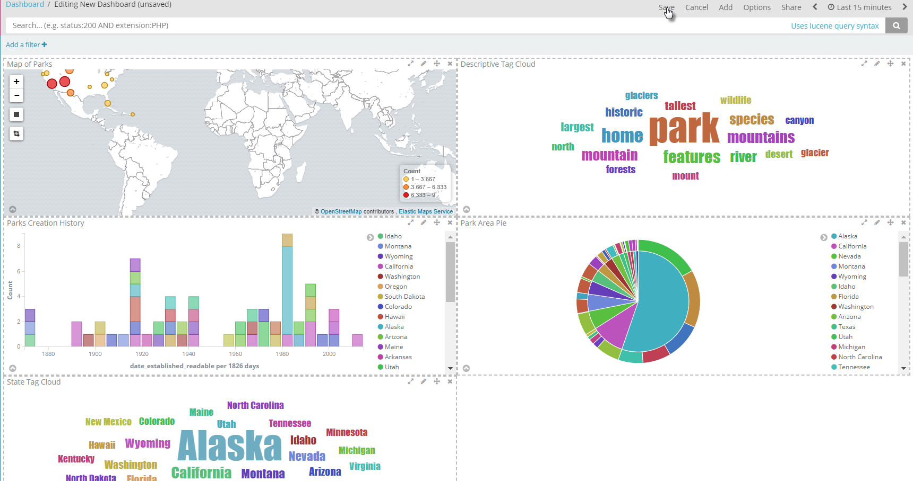

Then click on Save.

Provide name: *National Parks Dashboard*

And description: *Interactive Overview of US National Parks*

Then click on Save

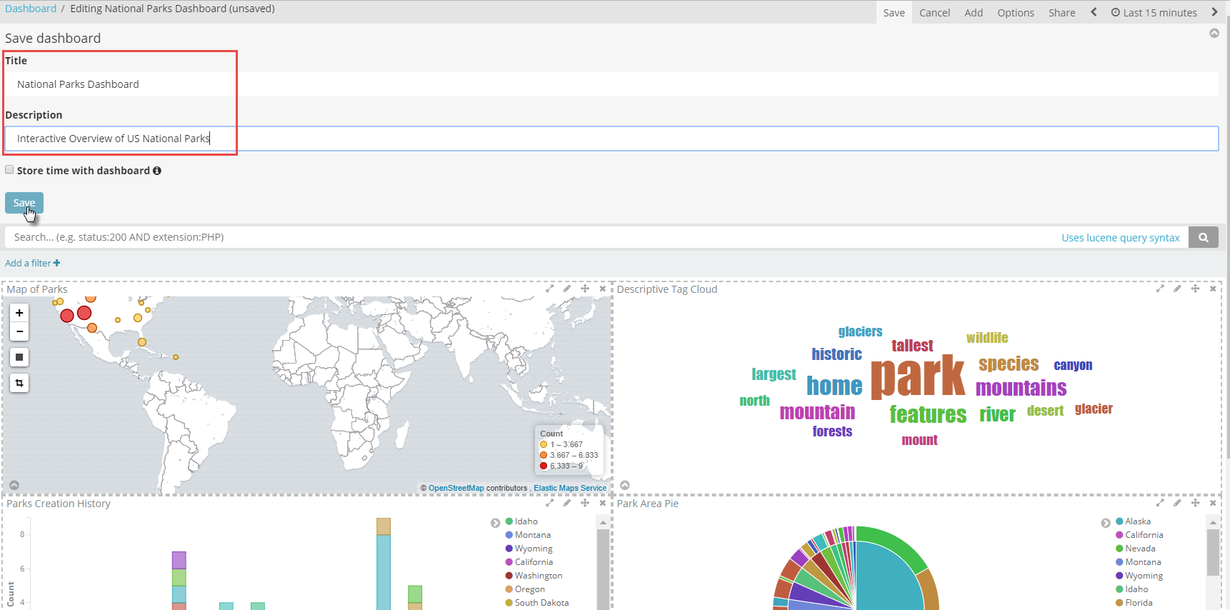

The dashboard is saved:

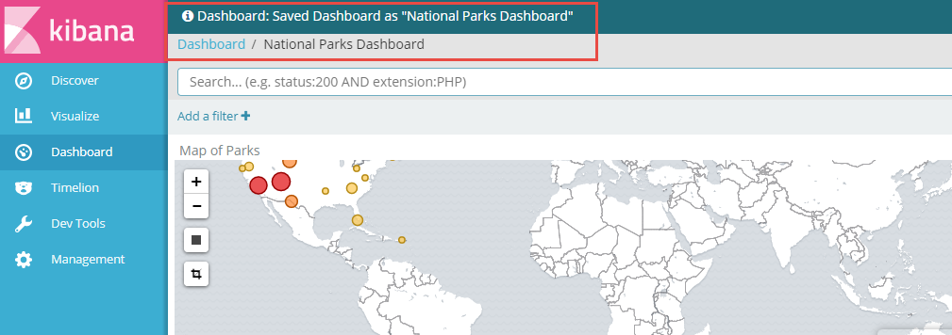

This dashboard can now be shared – both as snapshot in time and as a live dashboard (dynamically updated with fresh data). A shared dashboard can be embedded in an IFRAME in web applications.

A powerful feature in the Dashboard is the search filter.

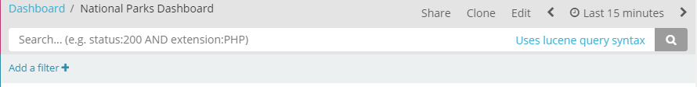

Users can use the search filter to slice and dice the data from the *parks* index – and in doing so filter the data for all visualizations.

For example, type *forest* in the search bar. This results in all visualizations only showing data for national parks with forest in their definition:

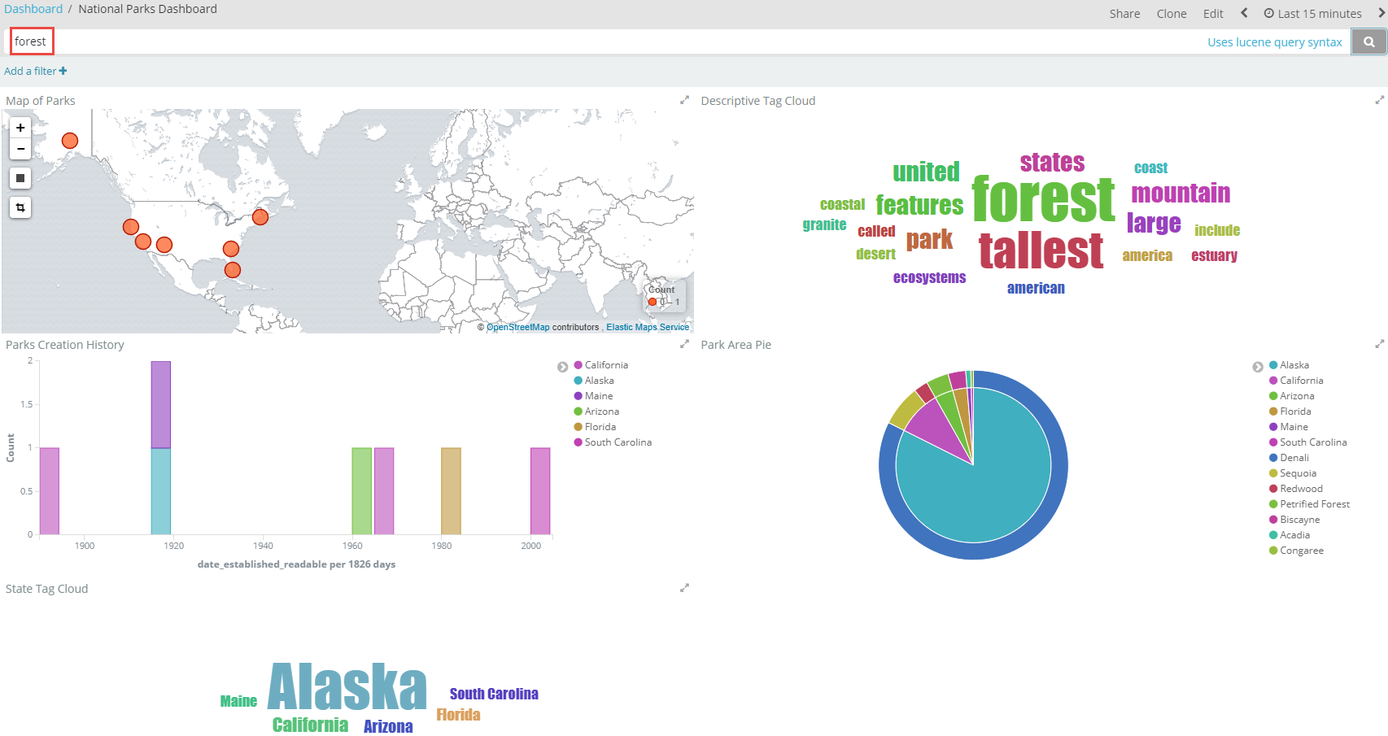

Additionally, clicking on pie chart slices, tag cloud tags, stack segments in the bar chart will result in new filters in the query. For example clicking on the tag California will result in only the parks in California being available to all visualizations.

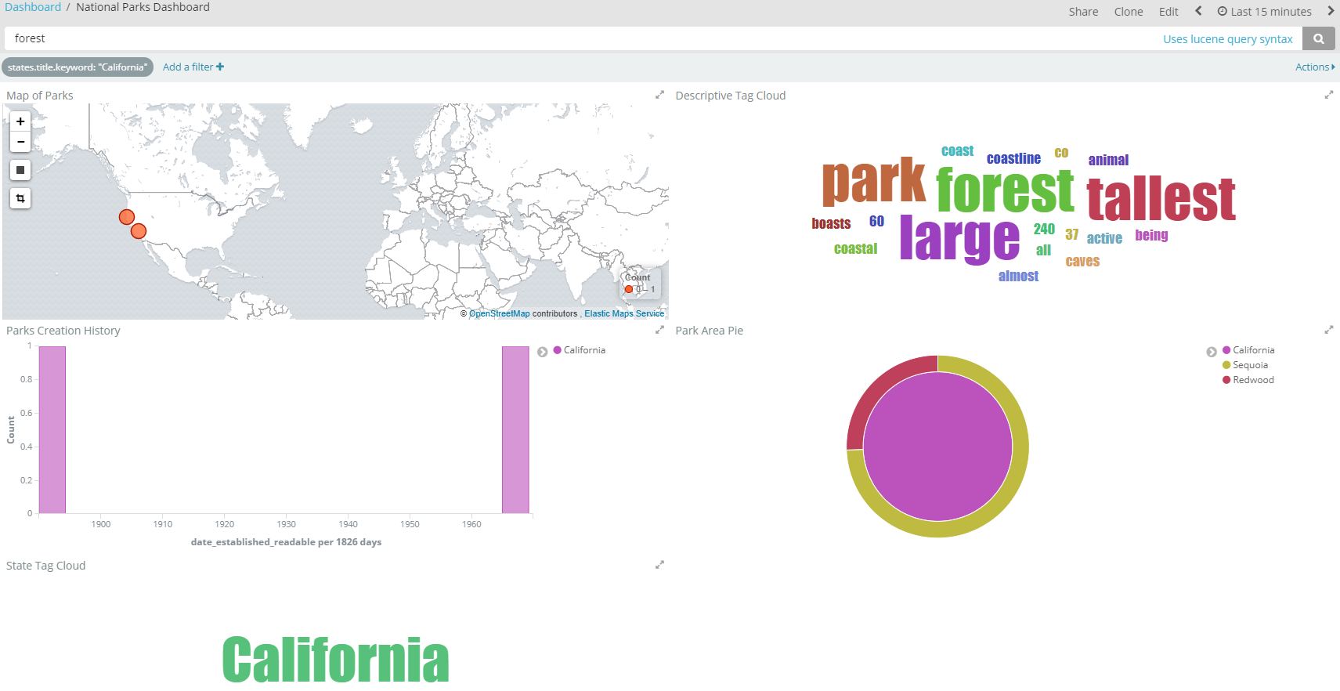

# 3. Getting Started with Elastic Search

A(nother) good way to get started with Elastic Search Index – creating an index, creating some data, performing some queries - is through this tutorial: <http://joelabrahamsson.com/elasticsearch-101/> (even though it is already quite old – the basic principles are all still valid). Go to the heading CRUD to start your interaction with Elastic Search:  
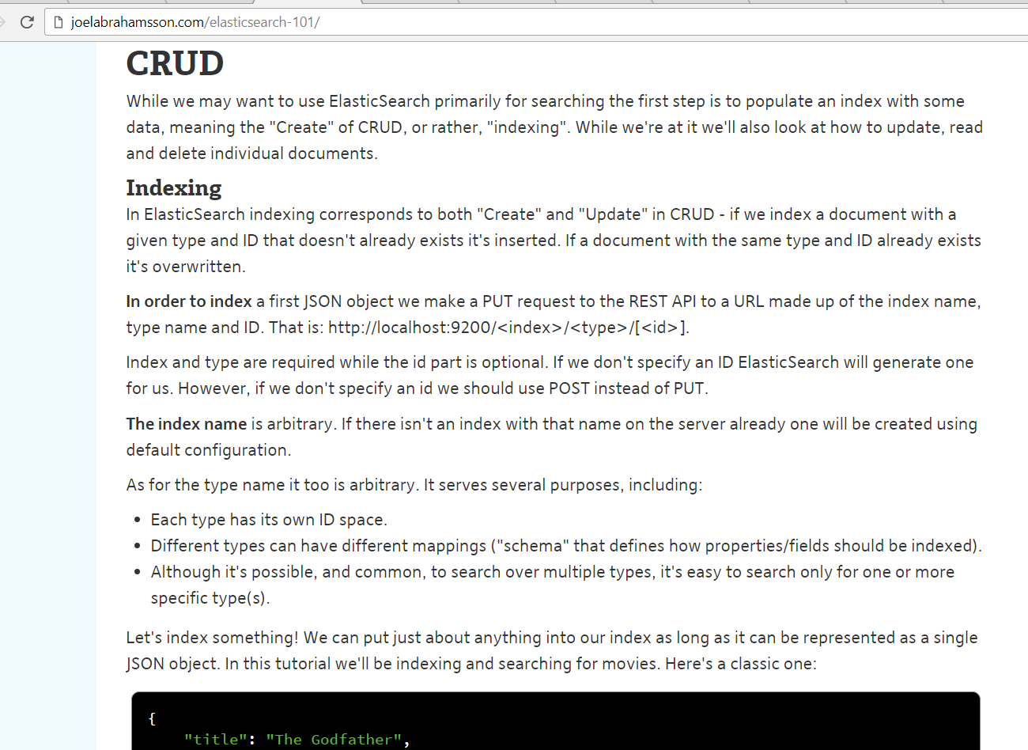

# 4. Getting Started with Kibana

The website of the Elastic Company provides a great tutorial for getting started with Kibana. This tutorial shows you how to:

* Load a sample data set into Elasticsearch
* Define an index pattern in Kibana
* Explore the sample data with [Discover](https://www.elastic.co/guide/en/kibana/6.1/discover.html)
* Set up [visualizations](https://www.elastic.co/guide/en/kibana/6.1/visualize.html) of the sample data
* Assemble visualizations into a [Dashboard](https://www.elastic.co/guide/en/kibana/6.1/dashboard.html)

Access this tutorial at: <https://www.elastic.co/guide/en/kibana/current/getting-started.html>

Note: Kibana visualizations can be embedded in web applications very easily. See this tutorial for the instruction: <https://www.elastic.co/blog/kibana-4-video-tutorials-part-4> (it is nothing more than embedded a snippet of HTML)

# 5. Explore LogStash + Elastic Search + Kibana in fully hosted environment

To get a feel for processing, storing, analyzing and exploring log file entries – one of the most prominent use cases of the Elastic Stack – you could take a look at a tutorial that provides a handson experience in a hosted environment.

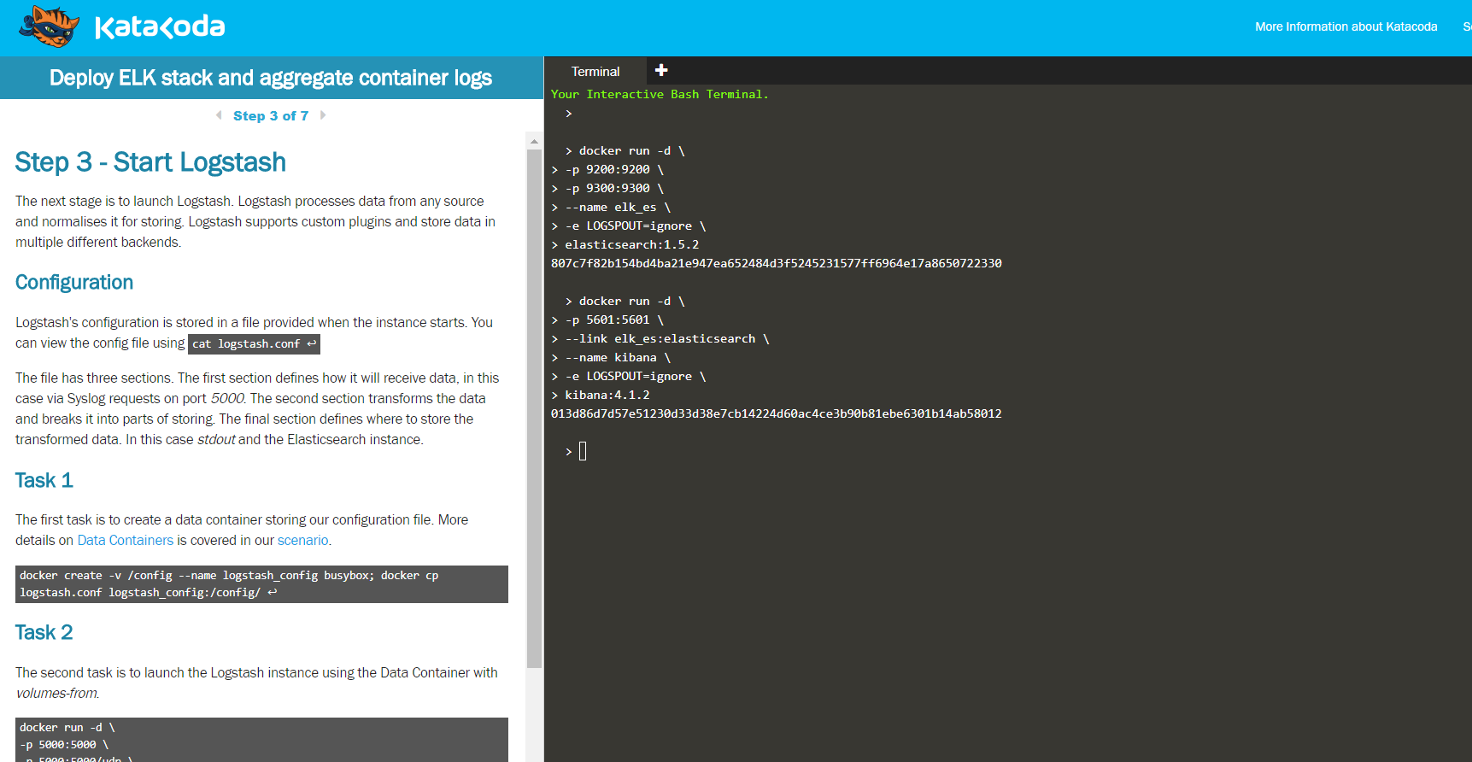

Access this tutorial at KataKoda - <https://www.katacoda.com/courses/docker-production/launch-elk-aggregate-container-logs> .

# 6. Client Libraries for Programmatic Interaction with Elastic Search

Any technology capable of making HTTP REST calls and manipulating JSON can use the generic REST APIs of Elastic Search to interact with any index. Additionally, a number of client libraries is available, that make this interaction easier - higher level, more native and therefore easier and more productive.

An example is the Java High Level REST Client (see: <https://www.elastic.co/guide/en/elasticsearch/client/java-rest/current/java-rest-high.html> ). This is a Java library that you can use in your own application (and that will still perform REST calls under the hood). See this tutorial for a concrete example: <https://qbox.io/blog/rest-calls-new-java-elasticsearch-client-tutorial> .

Client libraries are available for other programming languages as well, such as:

* Python: <https://elasticsearch-py.readthedocs.io/en/master/> (low level) and <https://elasticsearch-dsl.readthedocs.io/en/latest/> (high level).
* PHP: <https://www.elastic.co/guide/en/elasticsearch/client/php-api/current/index.html>
* JavaScript Node (server side)/Browser - <https://github.com/elastic/elasticsearch-js> ; see this tutorial for a quick start introduction: <https://qbox.io/blog/integrating-elasticsearch-into-node-js-application>
* Ruby (and Rails): <https://github.com/elastic/elasticsearch-rails>
* .Net: <https://github.com/elastic/elasticsearch-net>

## Introduction to the Node Client Library for Elastic

See the sources on GitHub (<https://github.com/lucasjellema/sig-elasticsearch-february-2018> ), specifically in directory *elastic-node-app*.

Check in package.json: the dependency on NPM module *elasticsearch*. See: <https://github.com/elastic/elasticsearch-js> for the documentation for this module.

Then open file index.js. The salient parts:

* Connecting to the Elastic Search Server
* Executing (complex) queries – with multiple query and filter clauses - and processing the responses
* Adding data to the index